Page 1 of 21
Report No.: LCSA022523032R001
Verification Report
Applicant
Address
:
:
Shenzhen Damin Energy Technology Co., Ltd
B717, Tang Shang Building, No. 35 Xinqiao Section of Guangshen Road,
Shangxing Community, Xinqiao Street, Baoan District, Shenzhen City,
Guangdong Province,China
Report on the submitted samples said to be:
Sample Name(s)
Trade Mark
:
:
:
:
:
:
:
:
Jump Starter
N/A
Part No.
CAT797
Sample Received Date
Testing Period
Date of Report
Testing Location
Results
March 03, 2023
March 03, 2023 ~ March 09, 2023
March 10, 2023 ~ March 15, 2023
March 27, 2024
901, No.40 Building, Xialang Industrial Zone, Heshuikou Community,
Matian Street, Guangming District, Shenzhen, Guangdong, China
Please refer to next page(s).
TEST REQUEST
CONCLUSION
As specified by client, based on the performed tests on submitted sample, the result of
Lead(Pb), Cadmium(Cd), Mercury(Hg), Hexavalent Chromium(Cr(VI)), PBBs, PBDEs,
Dibutyl Phthalate(DBP), Butylbenzyl Phthalate(BBP), Di-2-ethylhexyl
PASS
Phthalate(DEHP) and Diisobutyl phthalate(DIBP) content comply with the limits set by
RoHS Directive 2011/65/EU with amendment (EU) 2015/863.
Signed for and on behalf of LCS
Terry Luo
Shenzhen LCS Compliance Testing Laboratory Ltd.
Add: 901, No.40 Building, Xialang Industrial Zone, Heshuikou Community, Matian Street, Guangming District,
Shenzhen, Guangdong, China
Tel: +(86) 0755-82591330 | E-mail: webmaster@lcs-cert.com | Web: www.lcs-cert.com
Scan code to check authenticity
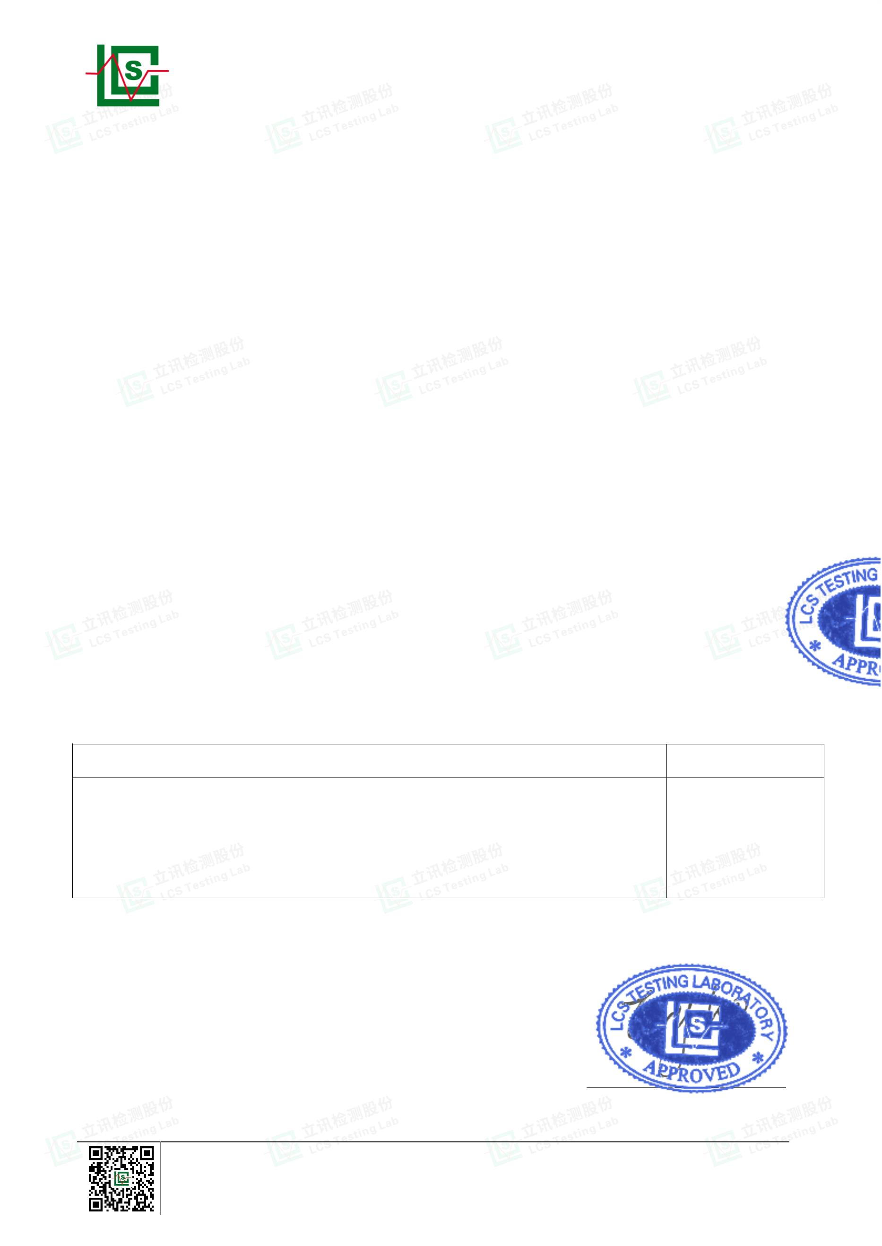

Page 2 of 21
Report No.: LCSA022523032R001
Results:
A. EU RoHS Directive 2011/65/EU and its amendment directives
Test method: With reference to IEC 62321-1:2013&IEC 62321-2:2021&IEC 62321-3-1:2013, Screening by
X-ray Fluorescence Spectroscopy (XRF)
Results
Date of sample
submission/
Resubmission
Sample
No.
Sample
Description
Br▼
Cd
Pb
Hg
Cr▼
PBBs
PBDEs
1
2
Black plastic shell
Gold metal nut
BL
BL
BL
BL
BL
BL
BL
BL
BL
BL
BL
BL
BL
BL
BL
BL
BL
BL
BL
BL
BL
BL
BL
BL
BL
BL
BL
BL
BL
BL
BL
BL
BL
BL
BL
BL
BL
X
BL
BL
BL
BL
BL
BL
BL
BL
BL
BL
BL
BL
BL
BL
BL
BL
BL
BL
BL
BL
BL
BL
BL
BL
BL
BL
BL
BL
BL
BL
BL
BL
BL
BL
BL
BL
BL
X
BL
BL
/
2023-03-03
2023-03-03
2023-03-03
2023-03-03
2023-03-03
2023-03-03
2023-03-03
2023-03-03
2023-03-03
2023-03-03
2023-03-03
2023-03-03
2023-03-03
2023-03-03
2023-03-03
2023-03-03
2023-03-03
2023-03-03
2023-03-03
2023-03-03
2023-03-03
2023-03-03
/
3
Black plastic frame
White plastic plate
Black plastic sheet
Black label
BL
BL
BL
BL
BL
/
BL
BL
BL
BL
BL
/
4
5
6
7
Black foam block
Silver metal block
Black rubber sheet
Black tape
8
9
BL
BL
BL
/
BL
BL
BL
/
10
11
12
13
14
15
16
17
18
19
20
21
22
Black plastic key
Gold metal screw
Gold metal nut
/
/
Gold metal gasket
Black metal screw
Silver metal screw
Silver metal screw
Black rubber plug
Black plastic shell
Black plastic ring
Silver metal contact
Black plastic sleeve
/
/
/
/
/
/
BL
BL
BL
BL
BL
BL
BL
BL
BL
BL
BL
BL
/
/
BL
BL
BL
/
BL
BL
BL
/
BL
BL
Red plastic wire
cover
23
BL
BL
BL
BL
BL
BL
2023-03-03
Black plastic wire
leather
24
25
26
27
28
BL
BL
BL
BL
BL
BL
BL
BL
BL
BL
BL
BL
BL
BL
BL
BL
BL
BL
BL
BL
BL
/
BL
/
2023-03-03
2023-03-03
2023-03-03
2023-03-03
2023-03-03
Silver metal core
White plastic
terminal
BL
/
BL
/
Silver metal contact
Black plastic wire
leather
BL
BL
Red plastic wire
cover
29
BL
BL
BL
BL
BL
BL
2023-03-03
Shenzhen LCS Compliance Testing Laboratory Ltd.
Add: 901, No.40 Building, Xialang Industrial Zone, Heshuikou Community, Matian Street, Guangming District,
Shenzhen, Guangdong, China
Tel: +(86) 0755-82591330 | E-mail: webmaster@lcs-cert.com | Web: www.lcs-cert.com
Scan code to check authenticity
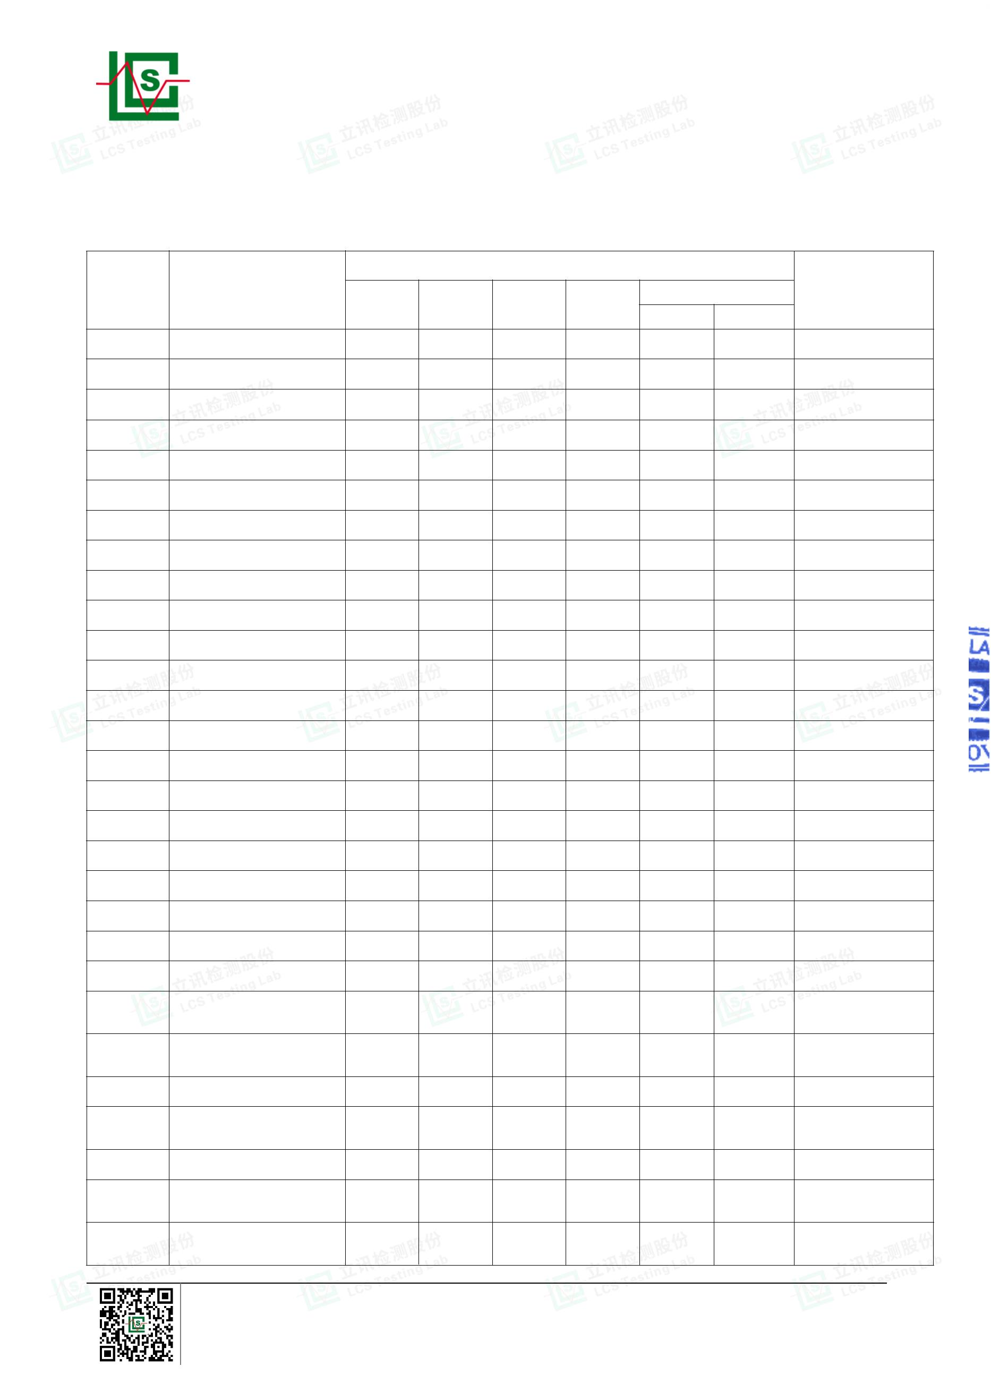

Page 3 of 21
Report No.: LCSA022523032R001
Results
Date of sample
submission/
Resubmission
Sample
No.
Sample
Description
Br▼
Cd
Pb
Hg
Cr▼
PBBs
PBDEs
30
31
Silver metal core
BL
BL
BL
BL
BL
BL
BL
BL
/
/
2023-03-03
2023-03-03
White plastic
terminal
BL
BL
32
33
Silver metal contact
White plastic PCB
BL
BL
BL
BL
BL
BL
BL
BL
/
/
2023-03-03
2023-03-03
X
X
White plastic LED
lamp
34
BL
BL
BL
BL
BL
BL
2023-03-03
35
36
37
38
39
40
41
42
43
44
45
46
47
48
Yellow plastic LED
Silver metal solder
Silver metal sheet
Black plastic key
Silver metal shrapnel
Black plastic base
Silver metal contact
Black plastic sheet
Silver metal solder
Silver metal shell
Silver metal sheet
Black plastic block
Silver metal stylus
Black plastic sleeve
BL
BL
BL
BL
BL
BL
BL
BL
BL
BL
BL
BL
BL
BL
BL
BL
BL
BL
BL
BL
BL
BL
BL
BL
BL
BL
BL
BL
BL
BL
BL
BL
BL
BL
BL
BL
BL
BL
BL
BL
BL
BL
BL
BL
BL
BL
BL
BL
BL
BL
BL
BL
BL
BL
BL
BL
BL
BL
2023-03-03
2023-03-03
2023-03-03
2023-03-03
2023-03-03
2023-03-03
2023-03-03
2023-03-03
2023-03-03
2023-03-03
2023-03-03
2023-03-03
2023-03-03
2023-03-03
/
/
/
BL
/
/
BL
/
BL
/
BL
/
BL
/
BL
/
/
/
/
/
BL
/
BL
/
BL
BL
Ferrous metal
magnetic coil
49
BL
BL
BL
BL
/
/
2023-03-03
50
51
52
53
Copper metal coil
Silver metal shell
Blue plastic block
Silver metal contact
BL
BL
BL
BL
BL
BL
BL
BL
BL
BL
BL
BL
BL
BL
BL
BL
/
/
/
/
2023-03-03
2023-03-03
2023-03-03
2023-03-03
BL
/
BL
/
Silver metal
aluminum shell
54
BL
BL
BL
BL
/
/
2023-03-03
55
56
57
58
59
60
61
62
Black matter
BL
BL
BL
BL
BL
BL
BL
BL
BL
BL
BL
BL
BL
BL
BL
BL
BL
BL
BL
BL
BL
BL
BL
BL
BL
BL
BL
BL
BL
BL
BL
BL
BL
BL
2023-03-03
2023-03-03
2023-03-03
2023-03-03
2023-03-03
2023-03-03
2023-03-03
2023-03-03
Black rubber pad
Silver metal pin
Black plastic PCB
Red plastic shell
Copper metal contact
Silver metal plate
Silver metal spring
BL
BL
/
X
BL
/
/
X
BL
/
/
/
/
/
Shenzhen LCS Compliance Testing Laboratory Ltd.
Add: 901, No.40 Building, Xialang Industrial Zone, Heshuikou Community, Matian Street, Guangming District,
Shenzhen, Guangdong, China
Tel: +(86) 0755-82591330 | E-mail: webmaster@lcs-cert.com | Web: www.lcs-cert.com
Scan code to check authenticity
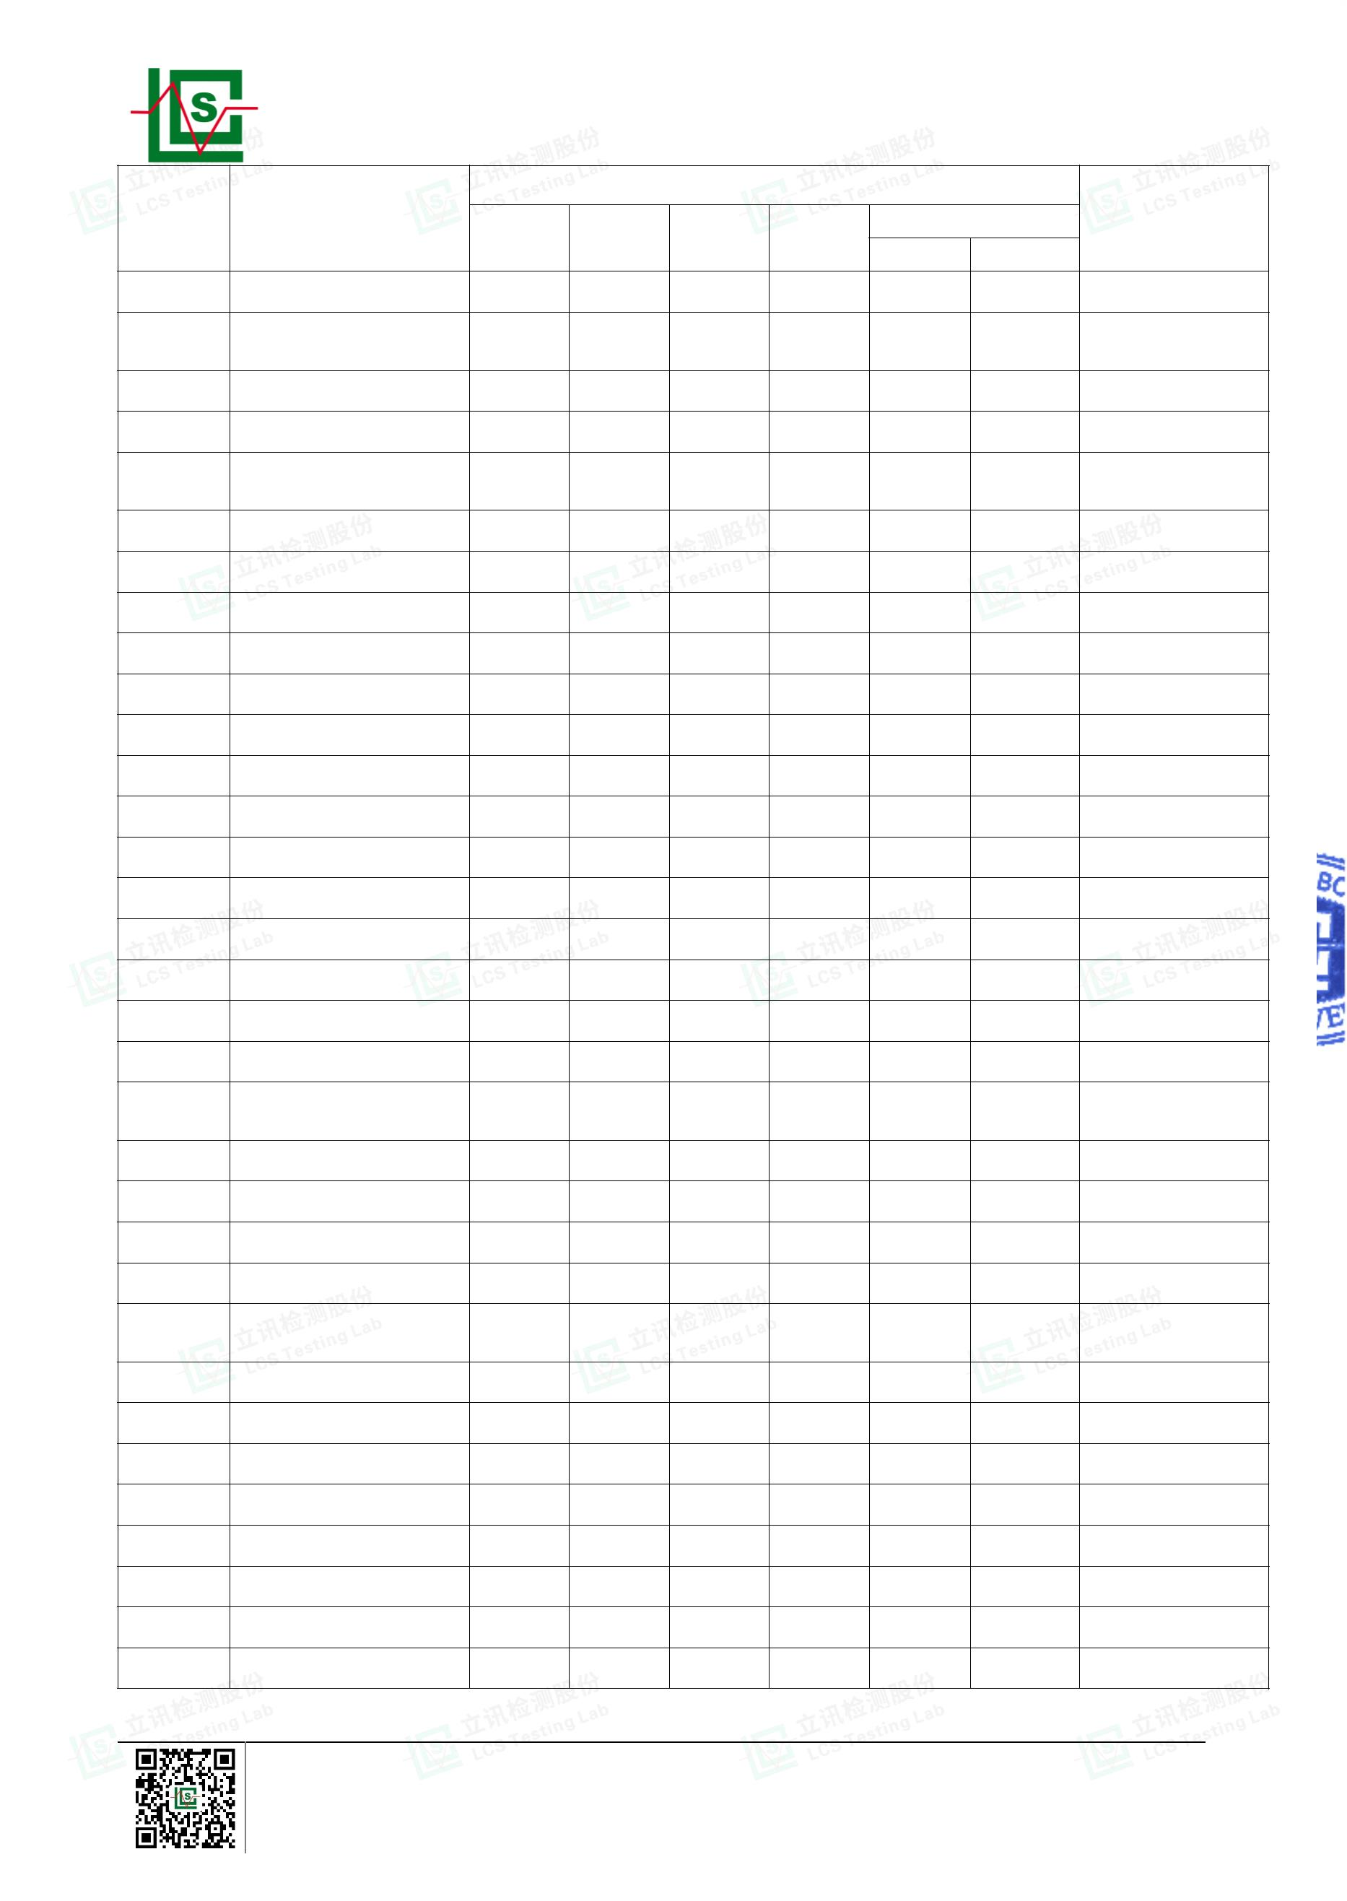

Page 4 of 21
Report No.: LCSA022523032R001
Results
Date of sample
submission/
Resubmission
Sample
No.
Sample
Description
Br▼
Cd
Pb
Hg
Cr▼
PBBs
PBDEs
Red plastic thick
leather
63
BL
BL
BL
BL
BL
BL
2023-03-03
64
65
66
Red plastic cover
Copper metal sheet
Black plastic shell
BL
BL
BL
BL
BL
BL
BL
BL
BL
BL
BL
BL
BL
/
BL
/
2023-03-03
2023-03-03
2023-03-03
BL
BL
Black plastic thick
leather
67
BL
BL
BL
BL
BL
BL
2023-03-03
68
69
70
71
72
73
74
Black plastic sleeve
Black plastic shell
Copper metal sheet
Copper metal core
Silver metal plate
Silver metal spring
Yellow tape
BL
BL
BL
BL
BL
BL
BL
BL
BL
BL
BL
BL
BL
BL
BL
BL
BL
BL
BL
BL
BL
BL
BL
BL
BL
BL
BL
BL
BL
BL
2023-03-03
2023-03-10
2023-03-10
2023-03-10
2023-03-10
2023-03-10
2023-03-10
BL
BL
/
/
/
/
/
/
/
/
BL
BL
Beige plastic
connector
75
BL
BL
BL
BL
BL
BL
2023-03-10
76
77
78
79
Silver metal stylus
Black plastic diode
Black plastic IC
Gray metal core
BL
BL
BL
BL
BL
BL
BL
BL
BL
BL
BL
BL
BL
BL
BL
BL
/
/
2023-03-10
2023-03-10
2023-03-10
2023-03-10
BL
BL
/
BL
BL
/
Brown plastic chip
capacitor
80
BL
BL
BL
BL
BL
BL
2023-03-10
81
82
Black plastic body
Black plastic shell
BL
BL
BL
BL
BL
BL
BL
BL
BL
BL
BL
BL
2023-03-10
2023-03-10
Silver metal
aluminum shell
83
BL
BL
BL
BL
/
/
2023-03-10
84
85
86
87
88
Yellow tape
BL
BL
BL
BL
BL
BL
BL
BL
BL
BL
BL
BL
BL
BL
BL
BL
BL
BL
BL
BL
BL
BL
BL
/
BL
BL
BL
/
2023-03-10
2023-03-10
2023-03-10
2023-03-10
2023-03-10
Black matter
Black rubber pad
Silver metal pin
Black plastic sleeve
BL
BL
Ferrous metal
magnetic coil
89
BL
BL
BL
BL
/
/
2023-03-10
90
91
92
93
94
95
Copper metal coil
Black plastic shell
Gold metal sheet
White ceramic
Silver metal pin
Red wire
BL
BL
BL
BL
BL
BL
BL
BL
BL
BL
BL
BL
BL
BL
BL
BL
BL
BL
BL
BL
BL
BL
BL
BL
/
BL
/
/
BL
/
2023-03-10
2023-03-10
2023-03-10
2023-03-10
2023-03-10
2023-03-10
BL
/
BL
/
/
/
Shenzhen LCS Compliance Testing Laboratory Ltd.
Add: 901, No.40 Building, Xialang Industrial Zone, Heshuikou Community, Matian Street, Guangming District,
Shenzhen, Guangdong, China
Tel: +(86) 0755-82591330 | E-mail: webmaster@lcs-cert.com | Web: www.lcs-cert.com
Scan code to check authenticity
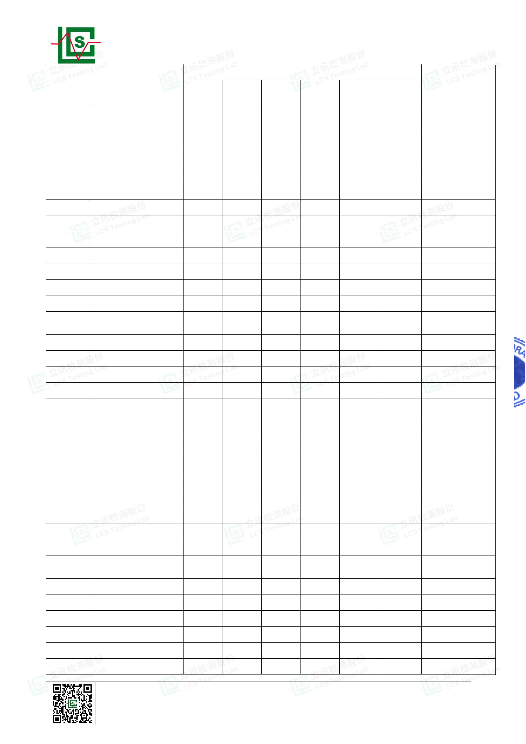

Page 5 of 21
Report No.: LCSA022523032R001
Results
Date of sample
submission/
Resubmission
Sample
No.
Sample
Description
Br▼
Cd
Pb
Hg
Cr▼
PBBs
BL
PBDEs
96
97
Black plastic chip
Black plastic PCB
Silver metal solder
Copper metal sheet
Gold metal nut
BL
BL
BL
BL
BL
BL
BL
BL
BL
BL
BL
BL
BL
BL
BL
BL
BL
BL
BL
BL
BL
2023-03-10
2023-03-10
2023-03-10
2023-03-10
2023-03-10
X
X
/
98
/
/
/
99
/
100
/
Note:
1. Results were obtained by XRF for primary screening, and further chemical testing by ICP(for Cd, Pb,
Hg), UV-Vis(for Cr(VI)) and GC-MS(for PBBs, PBDEs) are recommended to be performed, if the
concentration exceeds the below warning value according to IEC 62321-3-1:2013(Unit: mg/kg).
Element
Polymers
Metals
Composite material
Cd
Pb
Hg
Cr
Br
BL≤(70-3σ)<X<(130+3σ)≤OL
BL≤(70-3σ)<X<(130+3σ)≤OL
LOD<X<(150+3σ)≤OL
BL≤(700-3σ)<X<(1300+3σ)≤OL BL≤(700-3σ)<X<(1300+3σ)≤OL BL≤(500-3σ)<X<(1500+3σ)≤OL
BL≤(700-3σ)<X<(1300+3σ)≤OL BL≤(700-3σ)<X<(1300+3σ)≤OL BL≤(500-3σ)<X<(1500+3σ)≤OL
BL≤(700-3σ)<X
BL≤(300-3σ)<X
BL≤(700-3σ)<X
N/A
BL≤(500-3σ)<X
BL≤(250-3σ)<X
Remark:
-
-
-
-
-
-
BL= Below Limit
OL= Over Limit
X= The range of needing to do further testing
3σ= The reproducibility of analytical instruments
N/A= Not applicable
LOD= Detection limit
2. The XRF screening test for RoHS elements – The reading may be different to the actual content in the
sample be of non-uniformity composition.
3. The maximum permissible limit is quoted from the document RoHS Directive 2011/65/EU with
amendment (EU) 2015/863.
4. ▼=For restricted substances PBBs and PBDEs, the results show the total Br content, the restricted
substance was Cr(VI), and the results showed the total Cr content.
Shenzhen LCS Compliance Testing Laboratory Ltd.
Add: 901, No.40 Building, Xialang Industrial Zone, Heshuikou Community, Matian Street, Guangming District,
Shenzhen, Guangdong, China
Tel: +(86) 0755-82591330 | E-mail: webmaster@lcs-cert.com | Web: www.lcs-cert.com
Scan code to check authenticity
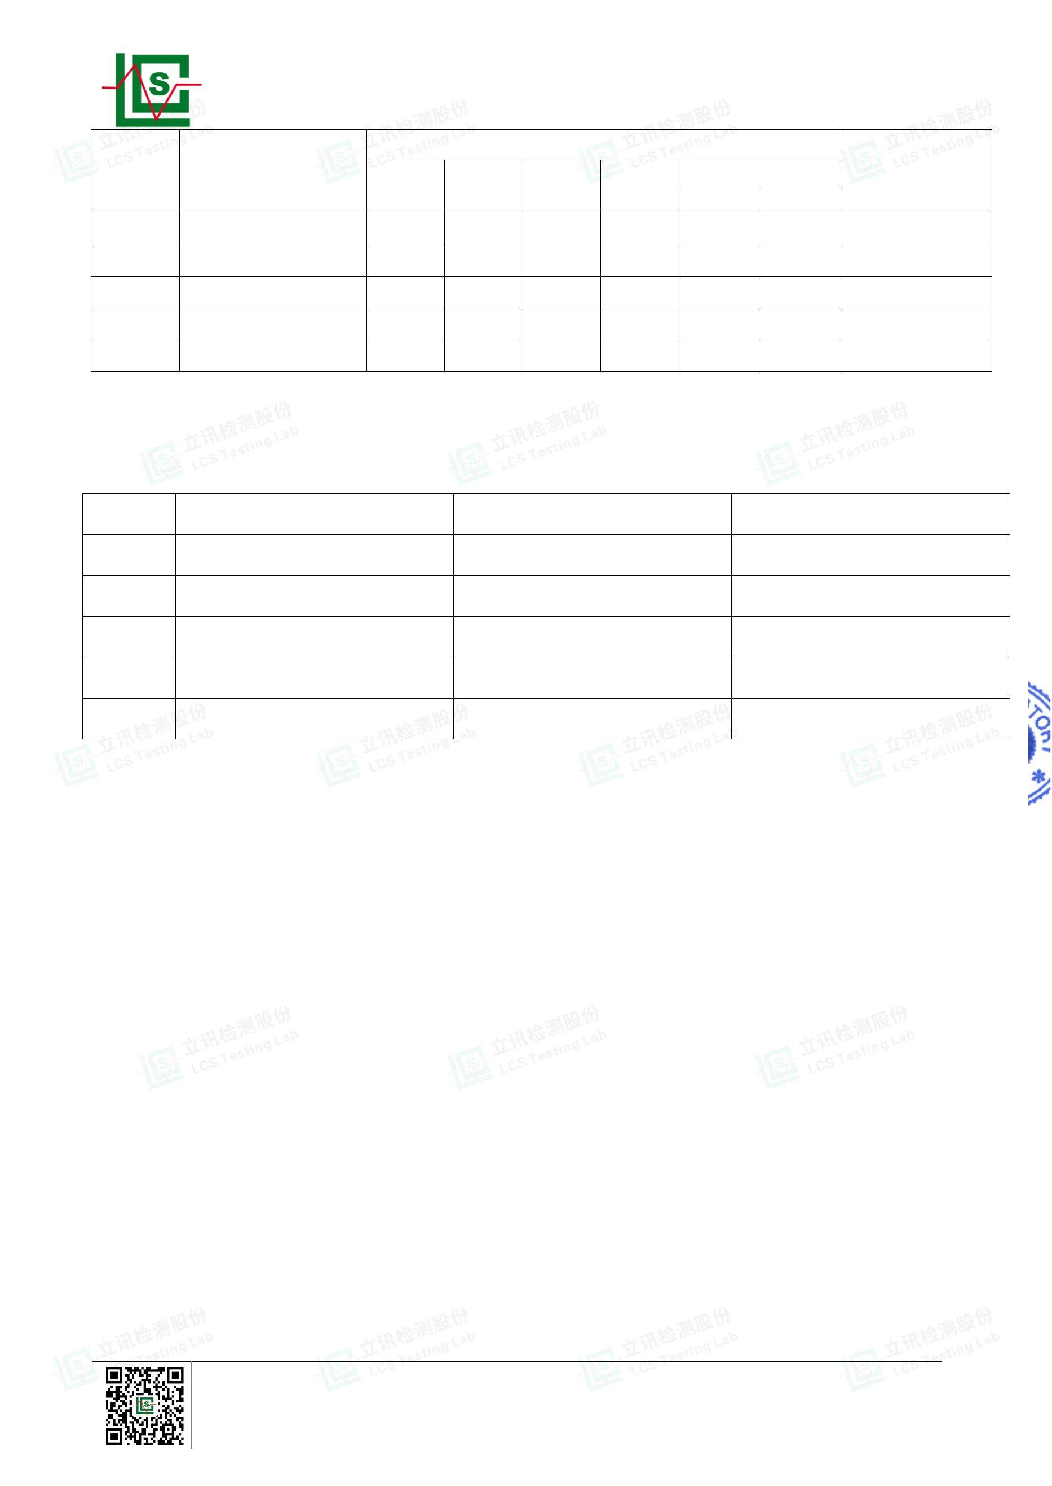

Page 6 of 21
Report No.: LCSA022523032R001
Maximum Concentration Value (mg/kg)
(by weight in homogenous materials)
RoHS Restricted Substances
Cadmium(Cd)
100
Lead(Pb)
1000
1000
1000
1000
1000
1000
1000
1000
1000
Mercury(Hg)
Hexavalent Chromium(Cr(VI))
Polybrominated biphenyls(PBBs)
Polybrominated diphenylethers(PBDEs)
Dibutyl Phthalate(DBP)
Butylbenzyl Phthalate(BBP)
Di-(2-ethylhexyl) Phthalate(DEHP)
Diisobutyl phthalate(DIBP)
Disclaimers:
This XRF Screening report is for reference purposes only. The applicant shall make its/his/her own
judgment as to whether the information provided in this XRF screening report is sufficient for its/his/her
purposes. The result shown in this XRF screening report will differ based on various factors, including but not
limited to, the sample size, thickness, area, surface flatness, equipment parameters and matrix effect (e.g.
plastic, rubber, metal, glass, ceramic etc.). Further wet chemical pre-treatment with relevant chemical
equipment analysis are required to obtain quantitative data.
Shenzhen LCS Compliance Testing Laboratory Ltd.
Add: 901, No.40 Building, Xialang Industrial Zone, Heshuikou Community, Matian Street, Guangming District,
Shenzhen, Guangdong, China
Tel: +(86) 0755-82591330 | E-mail: webmaster@lcs-cert.com | Web: www.lcs-cert.com
Scan code to check authenticity
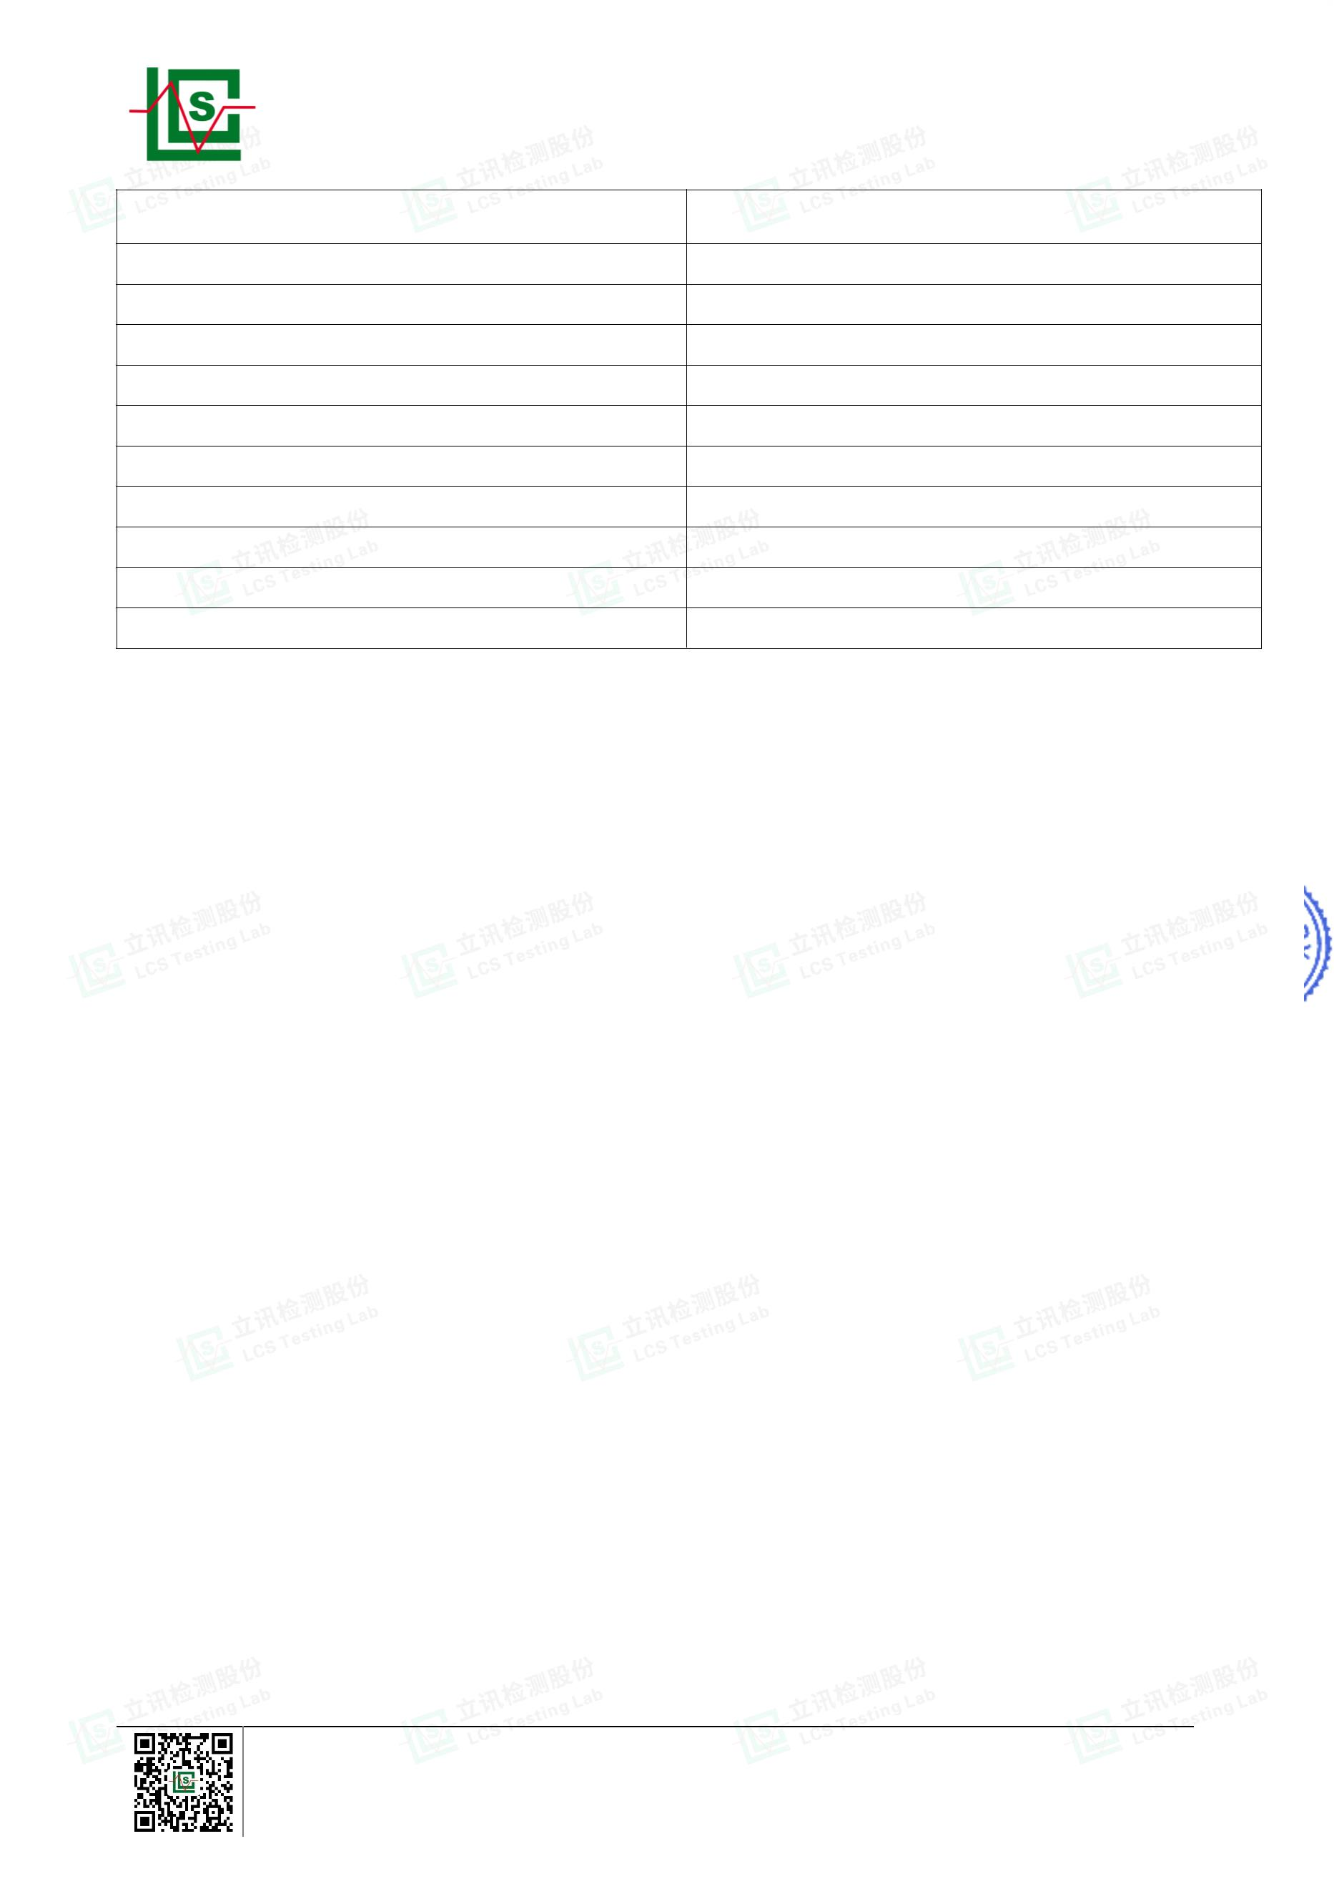

Page 7 of 21
Report No.: LCSA022523032R001
B. EU RoHS Directive 2011/65/EU with amendment (EU) 2015/863 on Lead(Pb), Cadmium(Cd),
Mercury(Hg), Hexavalent Chromium(Cr(VI)), PBBs, PBDEs, DBP, BBP, DEHP & DIBP content
Test method:
Lead(Pb) & Cadmium(Cd) Content:
With reference to IEC 62321-5:2013, by acid digestion and analysis was performed by inductively coupled
plasma optical emission spectrometer (ICP-OES) or atomic absorption spectrometer (AAS).
Mercury(Hg) Content:
With reference to IEC 62321-4:2013+AMD1:2017 CSV, by acid digestion and analysis was performed by
inductively coupled plasma optical emission spectrometer (ICP-OES).
Hexavalent Chromium(Cr(VI)) Content:
With reference to IEC 62321-7-1:2015 or IEC 62321-7-2:2017, analysis was performed by UV-visible
spectrophotometer (UV-Vis).
PBBs & PBDEs Content:
With reference to IEC 62321-6:2015, by solvent extraction and analysis was performed by gas
chromatographic-mass spectrometer (GC-MS).
Phthalates(DBP, BBP, DEHP &DIBP) Content:
With reference to IEC 62321-8:2017, by solvent extraction and analysis was performed by gas
chromatographic-mass spectrometer (GC-MS).
1) The test results of Lead(Pb)
Results
(mg/kg)
MDL
(mg/kg)
Limi
(mg/k
Tested Items
(16)
Lead(Pb) Content
5
42
1000
2) The test results of Hexavalent Chromium(Cr(VI)(for coating on metal)
Results
(μg/cm²)
MDL
(μg/cm²)
Limit
(μg/cm²)
Tested Items
(16)
0.10
(LOQ)
Hexavalent Chromium(Cr(VI)) Content★
N.D.
1000
3) The test results of Phthalates(DBP, BBP, DEHP &DIBP)
Results
(mg/kg)
MDL
(mg/kg)
Limit
(mg/kg)
Tested Items
23
24
28
29
Dibutyl Phthalate(DBP) Content
50
50
50
50
N.D.
N.D.
N.D.
N.D.
N.D.
N.D.
N.D.
N.D.
N.D.
N.D.
N.D.
N.D.
N.D.
N.D.
N.D.
N.D.
1000
1000
1000
1000
Butylbenzyl Phthalate(BBP) Content
Di-(2-ethylhexyl) Phthalate(DEHP) Content
Diisobutyl phthalate(DIBP) Content
Shenzhen LCS Compliance Testing Laboratory Ltd.
Add: 901, No.40 Building, Xialang Industrial Zone, Heshuikou Community, Matian Street, Guangming District,
Shenzhen, Guangdong, China
Tel: +(86) 0755-82591330 | E-mail: webmaster@lcs-cert.com | Web: www.lcs-cert.com
Scan code to check authenticity
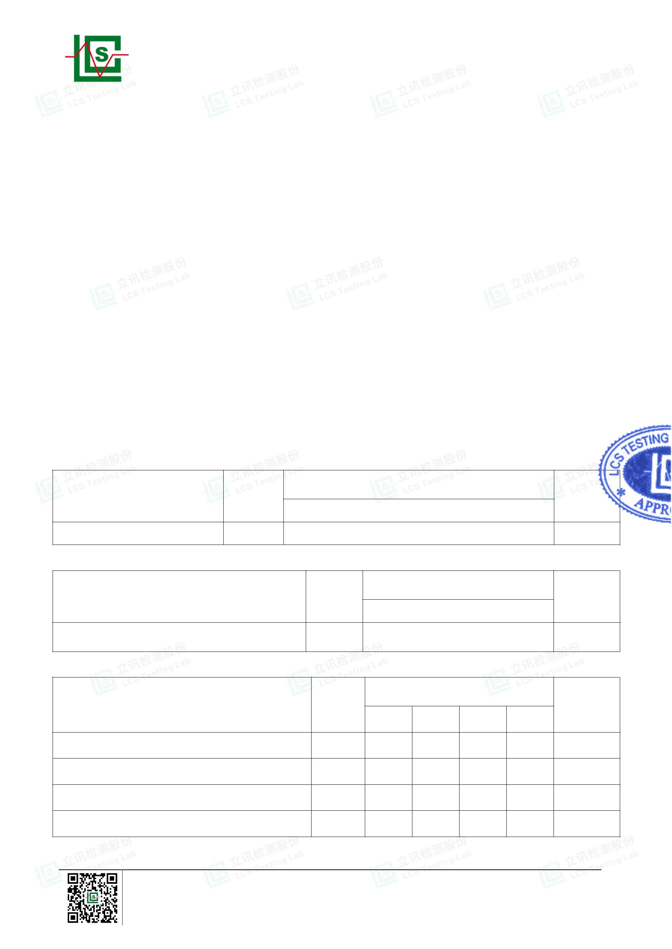

Page 8 of 21
Report No.: LCSA022523032R001
Results
MDL
(mg/kg)
(mg/kg)
Limit
(mg/kg)
Tested Items
33
58
Dibutyl Phthalate(DBP) Content
50
50
50
50
N.D.
N.D.
N.D.
N.D.
N.D.
N.D.
N.D.
N.D.
1000
1000
1000
1000
Butylbenzyl Phthalate(BBP) Content
Di-(2-ethylhexyl) Phthalate(DEHP) Content
Diisobutyl phthalate(DIBP) Content
Results
(mg/kg)
MDL
(mg/kg)
Limit
(mg/kg)
Tested Items
1+3+4+5+6+7
N.D.
Dibutyl Phthalate(DBP) Content
50
50
50
50
1000
1000
1000
1000
Butylbenzyl Phthalate(BBP) Content
Di-(2-ethylhexyl) Phthalate(DEHP) Content
Diisobutyl phthalate(DIBP) Content
N.D.
N.D.
N.D.
Results
(mg/kg)
MDL
(mg/kg)
Limit
(mg/kg)
Tested Items
9+10+11+18+19+20
Dibutyl Phthalate(DBP) Content
50
50
50
50
N.D.
N.D.
N.D.
N.D.
1000
1000
1000
1000
Butylbenzyl Phthalate(BBP) Content
Di-(2-ethylhexyl) Phthalate(DEHP) Content
Diisobutyl phthalate(DIBP) Content
Results
(mg/kg)
MDL
(mg/kg)
Limit
(mg/kg)
Tested Items
22+26+31+34+35+38
Dibutyl Phthalate(DBP) Content
50
50
50
50
N.D.
N.D.
N.D.
N.D.
1000
1000
1000
1000
Butylbenzyl Phthalate(BBP) Content
Di-(2-ethylhexyl) Phthalate(DEHP) Content
Diisobutyl phthalate(DIBP) Content
Shenzhen LCS Compliance Testing Laboratory Ltd.
Add: 901, No.40 Building, Xialang Industrial Zone, Heshuikou Community, Matian Street, Guangming District,
Shenzhen, Guangdong, China
Tel: +(86) 0755-82591330 | E-mail: webmaster@lcs-cert.com | Web: www.lcs-cert.com
Scan code to check authenticity
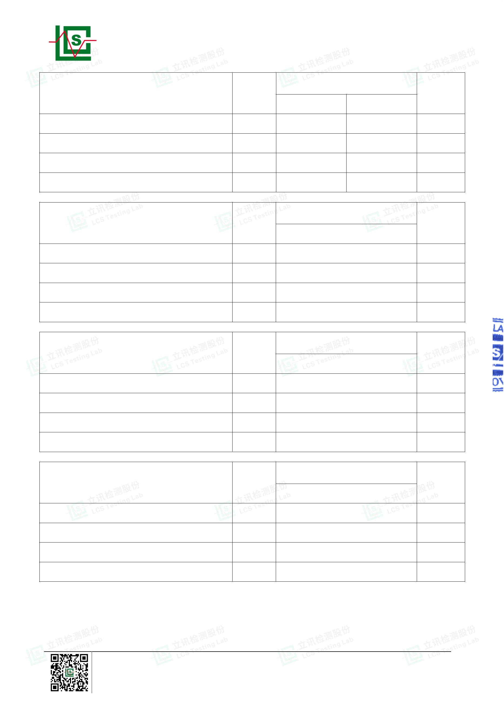

Page 9 of 21
Report No.: LCSA022523032R001
Results
MDL
(mg/kg)
(mg/kg)
Limit
(mg/kg)
Tested Items
40+42+46+48+52+55
Dibutyl Phthalate(DBP) Content
50
50
50
50
N.D.
N.D.
N.D.
N.D.
1000
1000
1000
1000
Butylbenzyl Phthalate(BBP) Content
Di-(2-ethylhexyl) Phthalate(DEHP) Content
Diisobutyl phthalate(DIBP) Content
Results
(mg/kg)
MDL
(mg/kg)
Limit
(mg/kg)
Tested Items
56+59+63+64+66+67
Dibutyl Phthalate(DBP) Content
50
50
50
50
N.D.
N.D.
N.D.
N.D.
1000
1000
1000
1000
Butylbenzyl Phthalate(BBP) Content
Di-(2-ethylhexyl) Phthalate(DEHP) Content
Diisobutyl phthalate(DIBP) Content
Results
(mg/kg)
MDL
(mg/kg)
Limit
(mg/kg)
Tested Items
68
Dibutyl Phthalate(DBP) Content
50
50
50
50
N.D.
N.D.
N.D.
N.D.
1000
1000
1000
1000
Butylbenzyl Phthalate(BBP) Content
Di-(2-ethylhexyl) Phthalate(DEHP) Content
Diisobutyl phthalate(DIBP) Content
Results
(mg/kg)
MDL
(mg/kg)
Limit
(mg/kg)
Tested Items
69+74+75+77+78+80
Dibutyl Phthalate(DBP) Content
50
50
50
50
N.D.
N.D.
N.D.
N.D.
1000
1000
1000
1000
Butylbenzyl Phthalate(BBP) Content
Di-(2-ethylhexyl) Phthalate(DEHP) Content
Diisobutyl phthalate(DIBP) Content
Shenzhen LCS Compliance Testing Laboratory Ltd.
Add: 901, No.40 Building, Xialang Industrial Zone, Heshuikou Community, Matian Street, Guangming District,
Shenzhen, Guangdong, China
Tel: +(86) 0755-82591330 | E-mail: webmaster@lcs-cert.com | Web: www.lcs-cert.com
Scan code to check authenticity
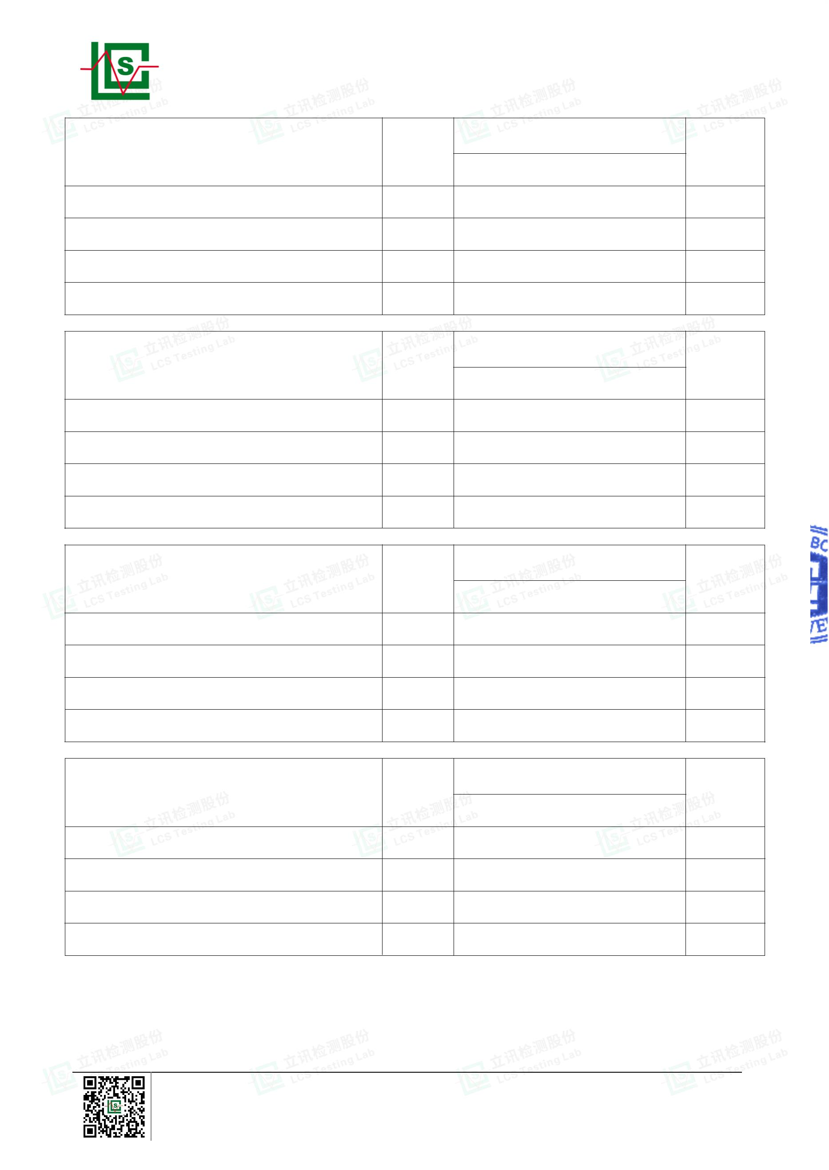

Page 10 of 21
Report No.: LCSA022523032R001
Results
MDL
(mg/kg)
(mg/kg)
Limit
(mg/kg)
Tested Items
81+82+84+85+86+88
Dibutyl Phthalate(DBP) Content
50
50
50
50
N.D.
N.D.
N.D.
N.D.
1000
1000
1000
1000
Butylbenzyl Phthalate(BBP) Content
Di-(2-ethylhexyl) Phthalate(DEHP) Content
Diisobutyl phthalate(DIBP) Content
Results
(mg/kg)
MDL
(mg/kg)
Limit
(mg/kg)
Tested Items
91+93+96+97
N.D.
Dibutyl Phthalate(DBP) Content
50
50
50
50
1000
1000
1000
1000
Butylbenzyl Phthalate(BBP) Content
Di-(2-ethylhexyl) Phthalate(DEHP) Content
Diisobutyl phthalate(DIBP) Content
N.D.
N.D.
N.D.
Shenzhen LCS Compliance Testing Laboratory Ltd.
Add: 901, No.40 Building, Xialang Industrial Zone, Heshuikou Community, Matian Street, Guangming District,
Shenzhen, Guangdong, China
Tel: +(86) 0755-82591330 | E-mail: webmaster@lcs-cert.com | Web: www.lcs-cert.com
Scan code to check authenticity
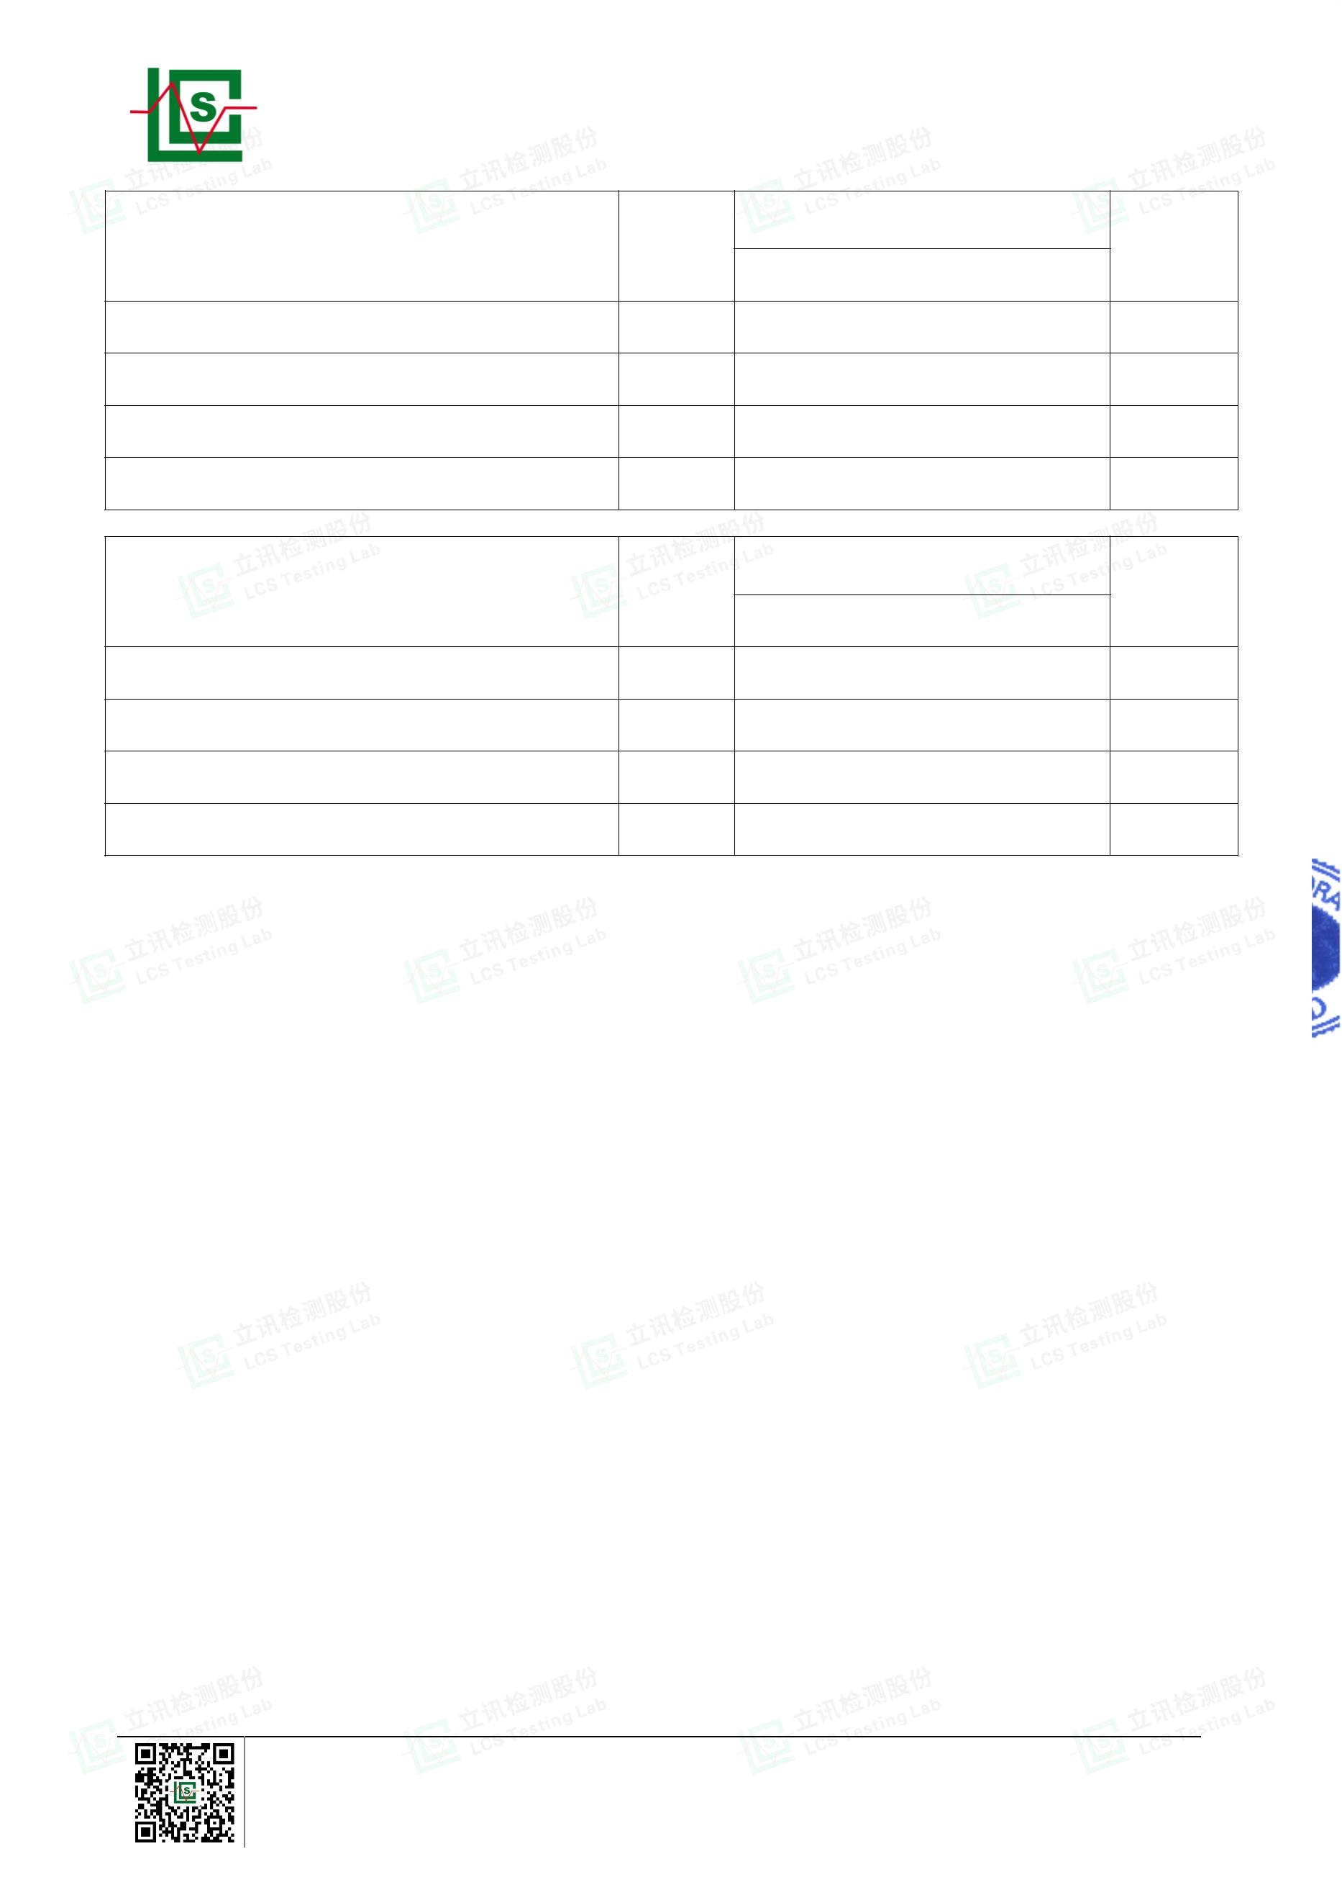

Page 11 of 21
Report No.: LCSA022523032R001
4) The test results of PBBs & PBDEs
Tested Items
Results
(mg/kg)
MDL
(mg/kg)
Limit
(mg/kg)
(33)
(58)
(97)
Polybrominated Biphenyls(PBBs) Content
Monobromobiphenyl
Dibromobiphenyl
5
5
5
5
5
5
5
5
5
5
/
N.D.
N.D.
N.D.
N.D.
N.D.
N.D.
N.D.
N.D.
N.D.
N.D.
N.D.
N.D.
N.D.
N.D.
N.D.
N.D.
N.D.
N.D.
N.D.
N.D.
N.D.
N.D.
N.D.
N.D.
N.D.
N.D.
N.D.
N.D.
N.D.
N.D.
N.D.
N.D.
N.D.
/
/
Tribromobiphenyl
/
Tetrabromobiphenyl
Pentabromobiphenyl
Hexabromobiphenyl
Heptabromobiphenyl
Octabromobiphenyl
Nonabromodiphenyl
Decabromodiphenyl
Total content
/
/
/
/
/
/
/
1000
Polybrominated Diphenylethers(PBDEs) Content
Monobromodiphenyl ether
Dibromodiphenyl ether
Tribromodiphenyl ether
Tetrabromodiphenyl ether
Pentabromodiphenyl ether
Hexabromodiphenyl ether
Heptabromodiphenyl ether
Octabromodiphenyl ether
Nonabromodiphenyl ether
Decabromodiphenyl ether
Total content
5
5
5
5
5
5
5
5
5
5
/
N.D.
N.D.
N.D.
N.D.
N.D.
N.D.
N.D.
N.D.
N.D.
N.D.
N.D.
N.D.
N.D.
N.D.
N.D.
N.D.
N.D.
N.D.
N.D.
N.D.
N.D.
N.D.
N.D.
N.D.
N.D.
N.D.
N.D.
N.D.
N.D.
N.D.
N.D.
N.D.
N.D.
/
/
/
/
/
/
/
/
/
/
1000
Shenzhen LCS Compliance Testing Laboratory Ltd.
Add: 901, No.40 Building, Xialang Industrial Zone, Heshuikou Community, Matian Street, Guangming District,
Shenzhen, Guangdong, China
Tel: +(86) 0755-82591330 | E-mail: webmaster@lcs-cert.com | Web: www.lcs-cert.com
Scan code to check authenticity
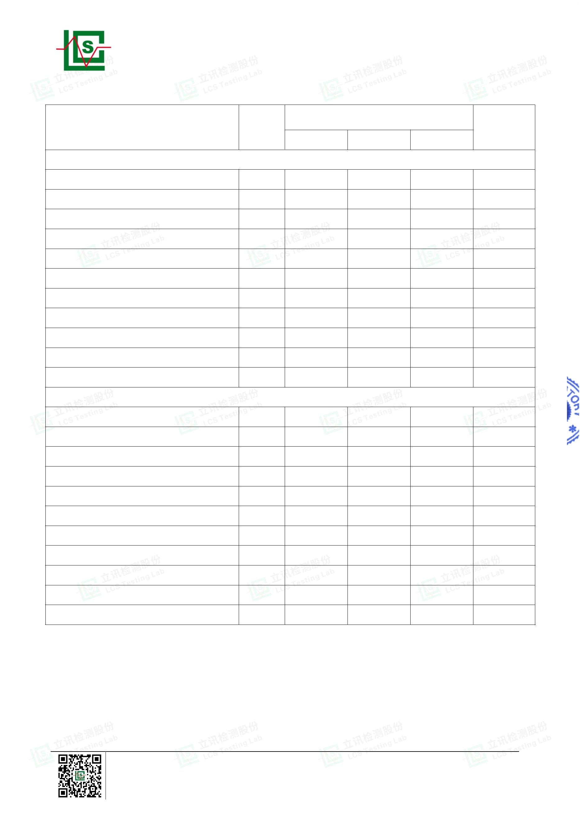

Page 12 of 21
Report No.: LCSA022523032R001
Note:
-
MDL = Method Detection Limit
-
-
-
-
N.D. = Not Detected (<MDL or LOQ)
mg/kg = milligrams per kilogram
LOQ = Limit Of Quantification, The LOQ of Hexavalent chromium is 0.10 μg/cm²
★ = a. The sample is positive for Cr(VI) if the Cr(VI) concentration is greater than 0.13μg/cm². The
sample coating is considered to contain Cr(VI).
b. The sample is negative for Cr(VI) if Cr(VI) is N.D.(concentration less than 0.10μg/cm²). The
sample coating is considered a non- Cr(VI) based coating.
c. The result between 0.10μg/cm² and 0.13μg/cm² is considered to be inconclusive, unavoidable
coating variations may influence the determination.
-
-
Information on storage conditions and production date of the tested samples is unavailable and thus
Cr(VI) results represent status of the sample at the time of testing.
According to customer's requirement, only the appointed materials have been tested.
Shenzhen LCS Compliance Testing Laboratory Ltd.
Add: 901, No.40 Building, Xialang Industrial Zone, Heshuikou Community, Matian Street, Guangming District,
Shenzhen, Guangdong, China
Tel: +(86) 0755-82591330 | E-mail: webmaster@lcs-cert.com | Web: www.lcs-cert.com
Scan code to check authenticity
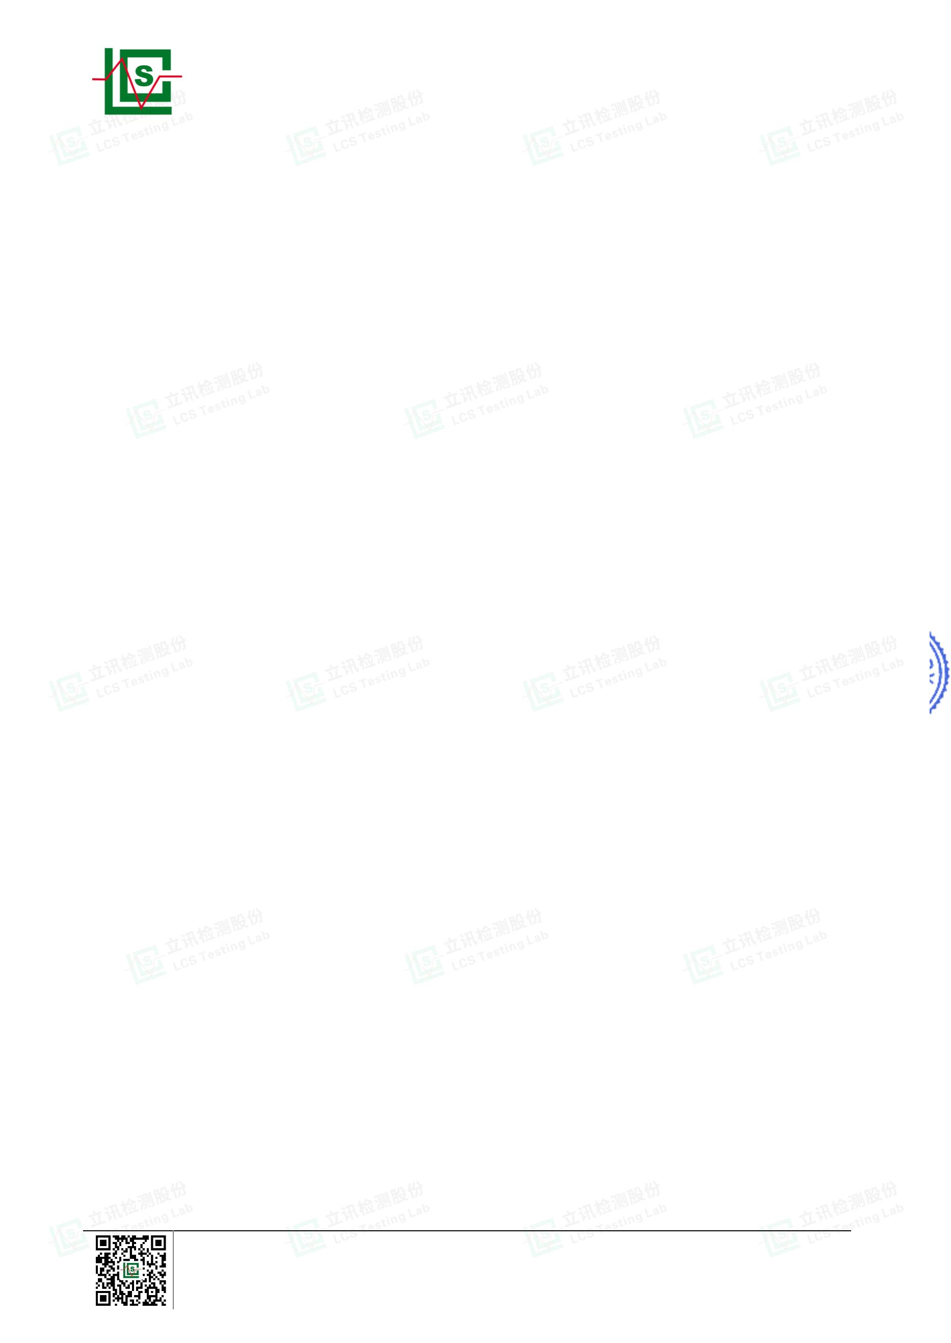

Page 13 of 21
Report No.: LCSA022523032R001
Test Process
1. Lead(Pb) & Cadmium(Cd): IEC 62321-5:2013
Weigh sample and place it
in a vessel
Add digestion reagent
Digest sample
Dry Ashing/
Alkali Fusion/
Acid Dissolution
Residue
Analyzed by
ICP-OES/AAS
Make up with
deionized water
Filtration
Solution
2. Mercury(Hg): IEC 62321-4:2013+AMD1:2017 CSV
Weigh sample and place it
Digest sample in microwave
digestion oven
Add digestion reagent
in a microwave digestion vessel
Alkali Fusion/
Acid Dissolution
Residue
Analyzed by
ICP-OES
Make up with
deionized water
Filtration
Solution
3. Hexavalent Chromium(Cr(VI))
1) IEC 62321-7-2:2017
Weigh sample and place
it a vessel
Add digestion reagent
Digest the sample
Cool and filter
Adjust the pH value of
the solution
Add the solution
Make up with
deionized water
Adjust the pH value
of the solution
Analyzed by UV-Vis
Shenzhen LCS Compliance Testing Laboratory Ltd.
Add: 901, No.40 Building, Xialang Industrial Zone, Heshuikou Community, Matian Street, Guangming District,
Shenzhen, Guangdong, China
Tel: +(86) 0755-82591330 | E-mail: webmaster@lcs-cert.com | Web: www.lcs-cert.com
Scan code to check authenticity
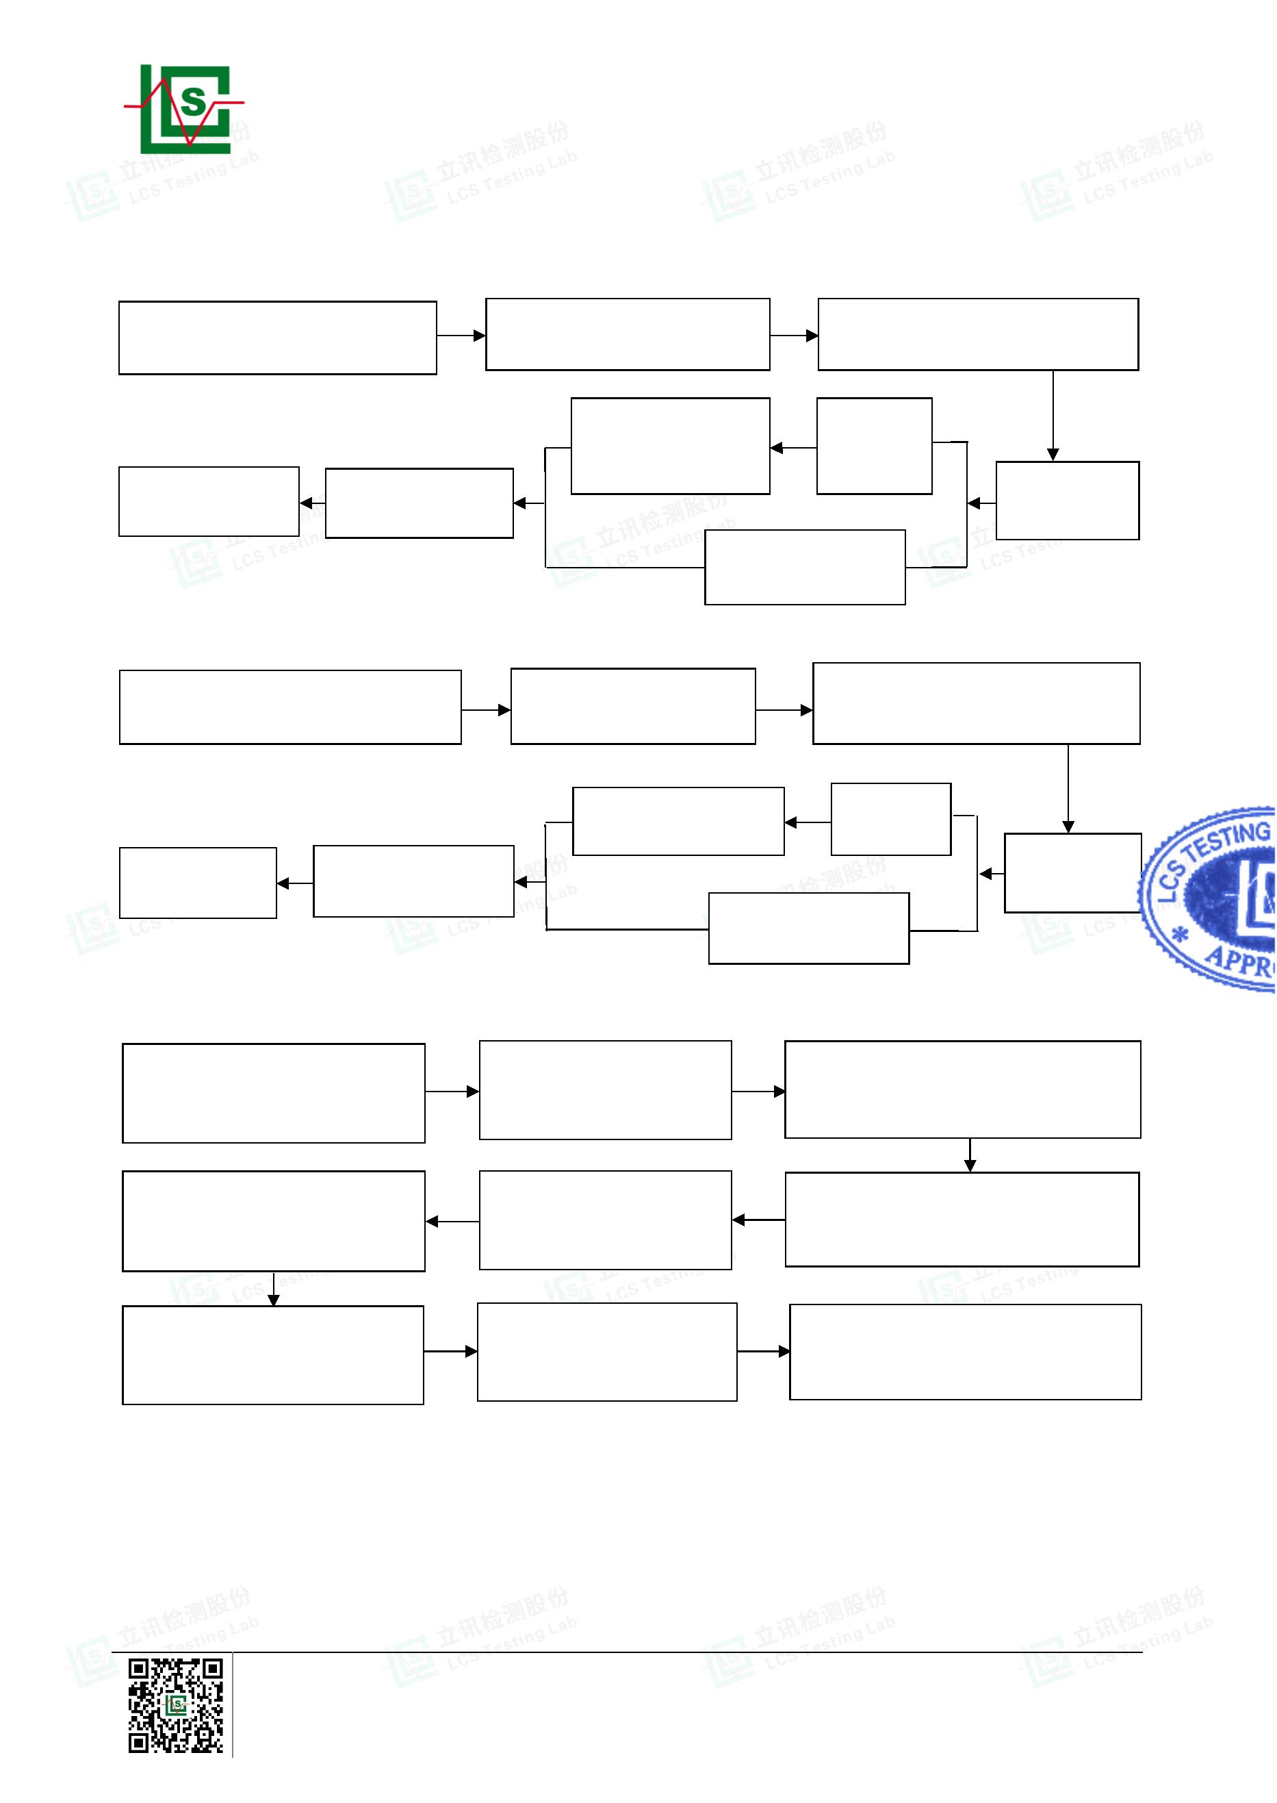

Page 14 of 21
Report No.: LCSA022523032R001
2) IEC 62321-7-1:2015
Take a portion
of the sample
Extracted with boiling
water
Filter and remove
the sample
Analyzed by
UV-Vis
Adjust the pH value
of the solution
Add test solution
4. Polybrominated Biphenyls(PBBs) & Polybrominated Diphenyl Ethers(PBDEs) : IEC 62321-6:2015
Weigh sample and place it
in a thimble
Extracted with organic
solvent
Concentrate the extract
Make up with organic
solvent
Transfer the extract into a
volumetric flask
Analyzed by GC-MS
5. Phthalates(DBP, BBP, DEHP & DIBP) : IEC 62321-8:2017
Weigh sample and place it
in a thimble
Extracted with organic
solvent
Concentrate the extract
Transfer the extract into a
volumetric flask
Make up with organic
solvent
Analyzed by GC-MS
Shenzhen LCS Compliance Testing Laboratory Ltd.
Add: 901, No.40 Building, Xialang Industrial Zone, Heshuikou Community, Matian Street, Guangming District,
Shenzhen, Guangdong, China
Tel: +(86) 0755-82591330 | E-mail: webmaster@lcs-cert.com | Web: www.lcs-cert.com
Scan code to check authenticity
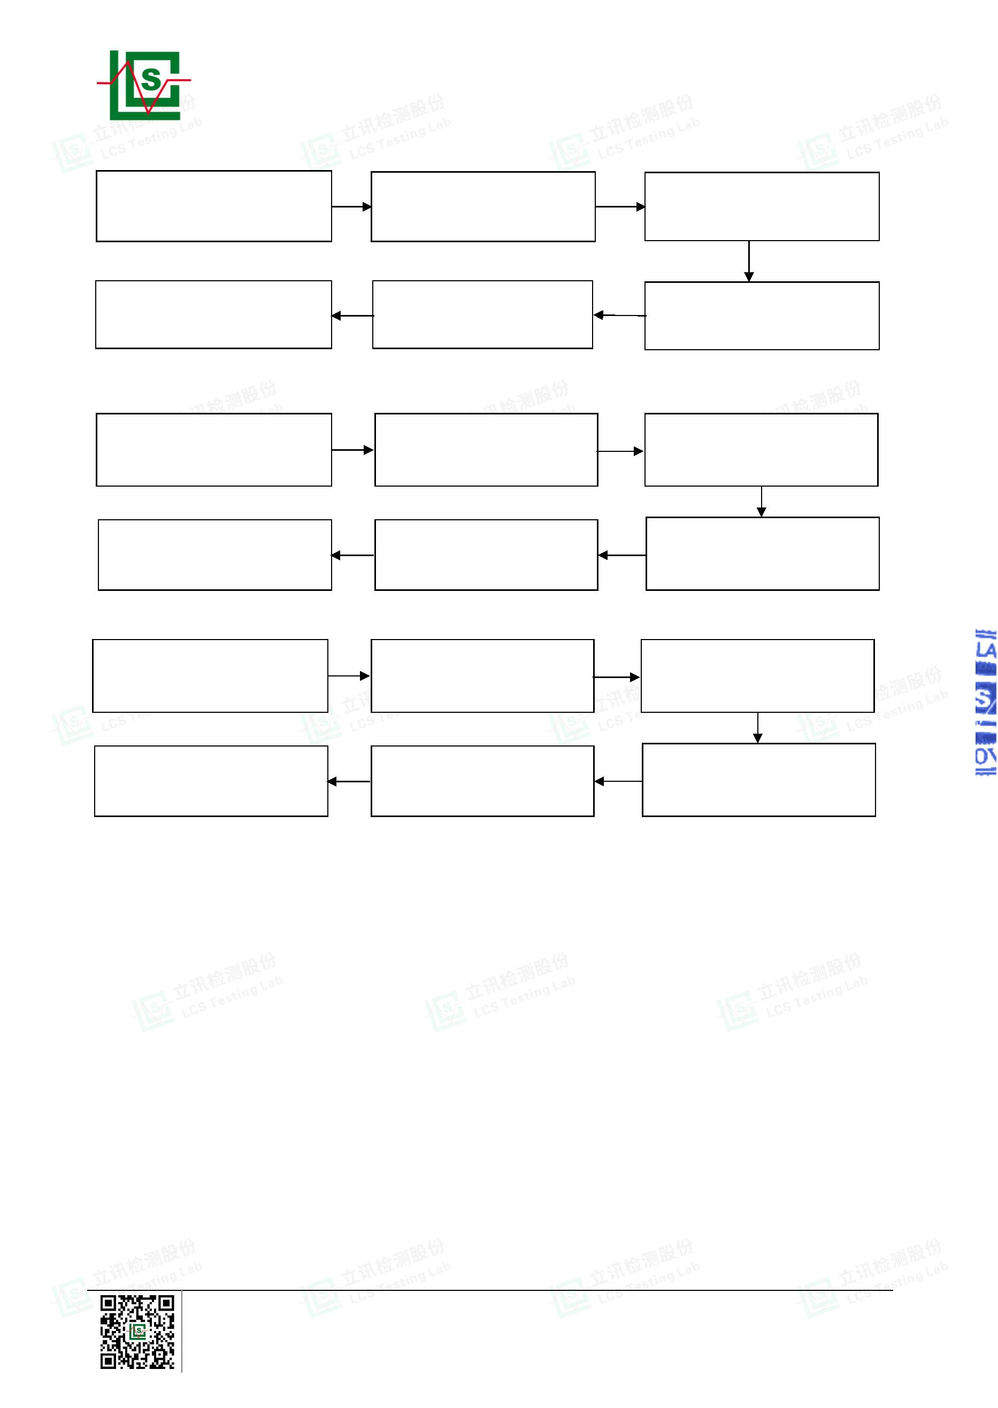

Page 15 of 21
Report No.: LCSA022523032R001
The photo(s) of the sample
Shenzhen LCS Compliance Testing Laboratory Ltd.
Add: 901, No.40 Building, Xialang Industrial Zone, Heshuikou Community, Matian Street, Guangming District,
Shenzhen, Guangdong, China
Tel: +(86) 0755-82591330 | E-mail: webmaster@lcs-cert.com | Web: www.lcs-cert.com
Scan code to check authenticity
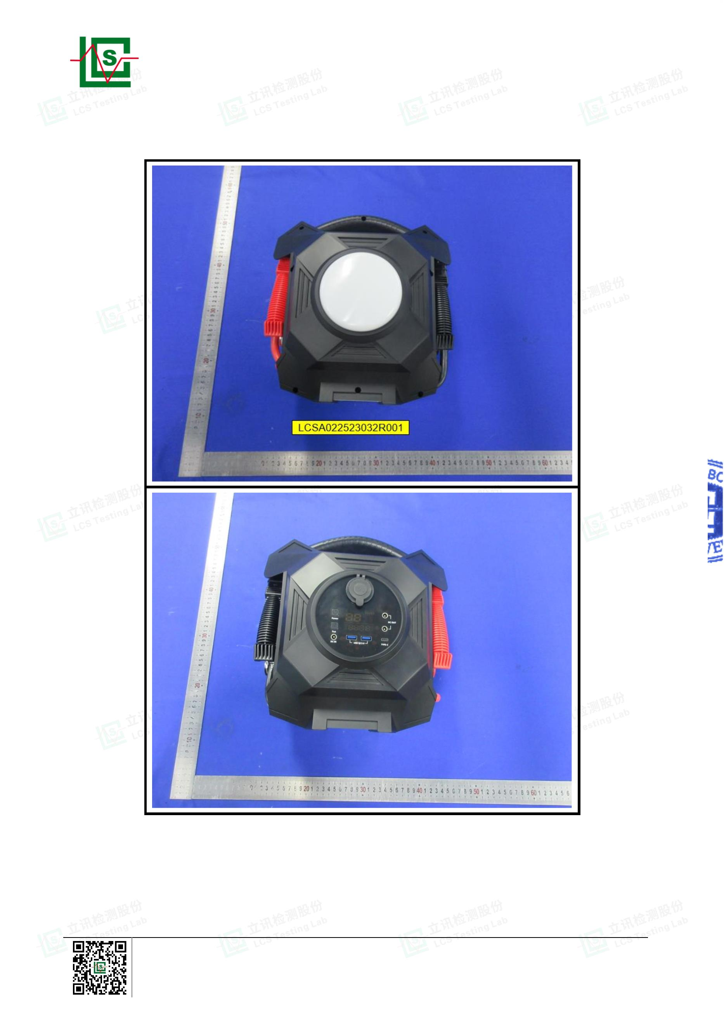

Page 16 of 21
Report No.: LCSA022523032R001
Shenzhen LCS Compliance Testing Laboratory Ltd.
Add: 901, No.40 Building, Xialang Industrial Zone, Heshuikou Community, Matian Street, Guangming District,
Shenzhen, Guangdong, China
Tel: +(86) 0755-82591330 | E-mail: webmaster@lcs-cert.com | Web: www.lcs-cert.com
Scan code to check authenticity
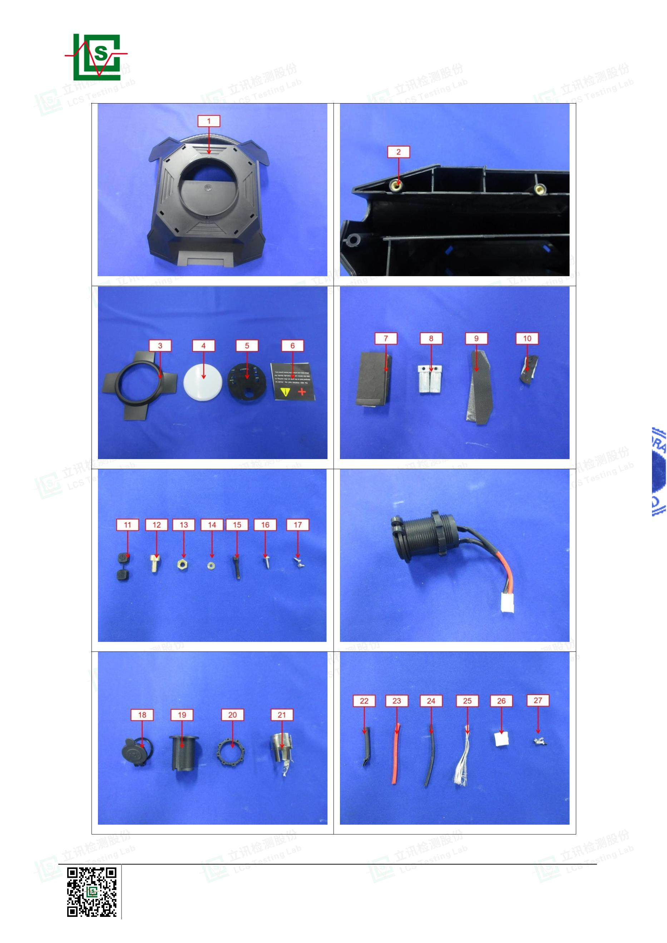

Page 17 of 21
Report No.: LCSA022523032R001
Shenzhen LCS Compliance Testing Laboratory Ltd.
Add: 901, No.40 Building, Xialang Industrial Zone, Heshuikou Community, Matian Street, Guangming District,
Shenzhen, Guangdong, China
Tel: +(86) 0755-82591330 | E-mail: webmaster@lcs-cert.com | Web: www.lcs-cert.com
Scan code to check authenticity
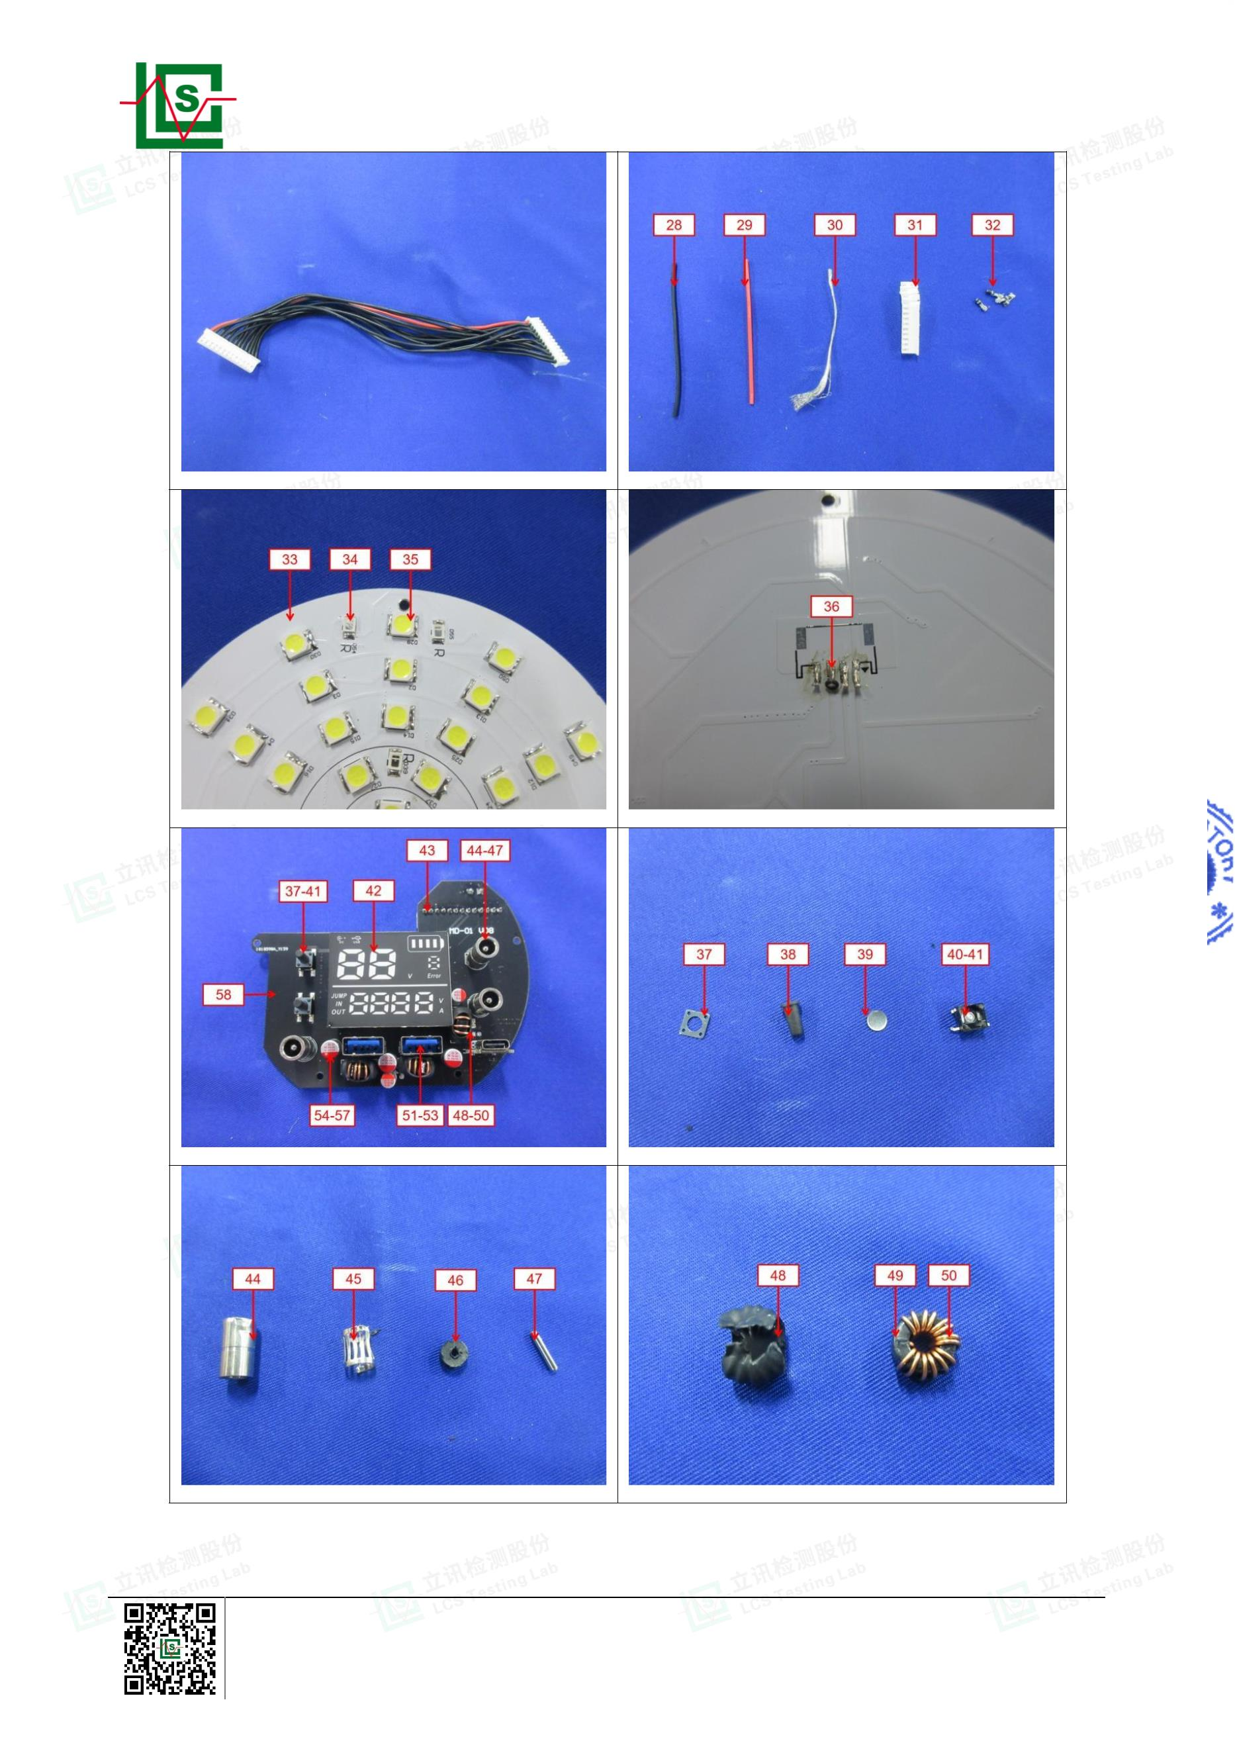

Page 18 of 21
Report No.: LCSA022523032R001
Shenzhen LCS Compliance Testing Laboratory Ltd.
Add: 901, No.40 Building, Xialang Industrial Zone, Heshuikou Community, Matian Street, Guangming District,
Shenzhen, Guangdong, China
Tel: +(86) 0755-82591330 | E-mail: webmaster@lcs-cert.com | Web: www.lcs-cert.com
Scan code to check authenticity
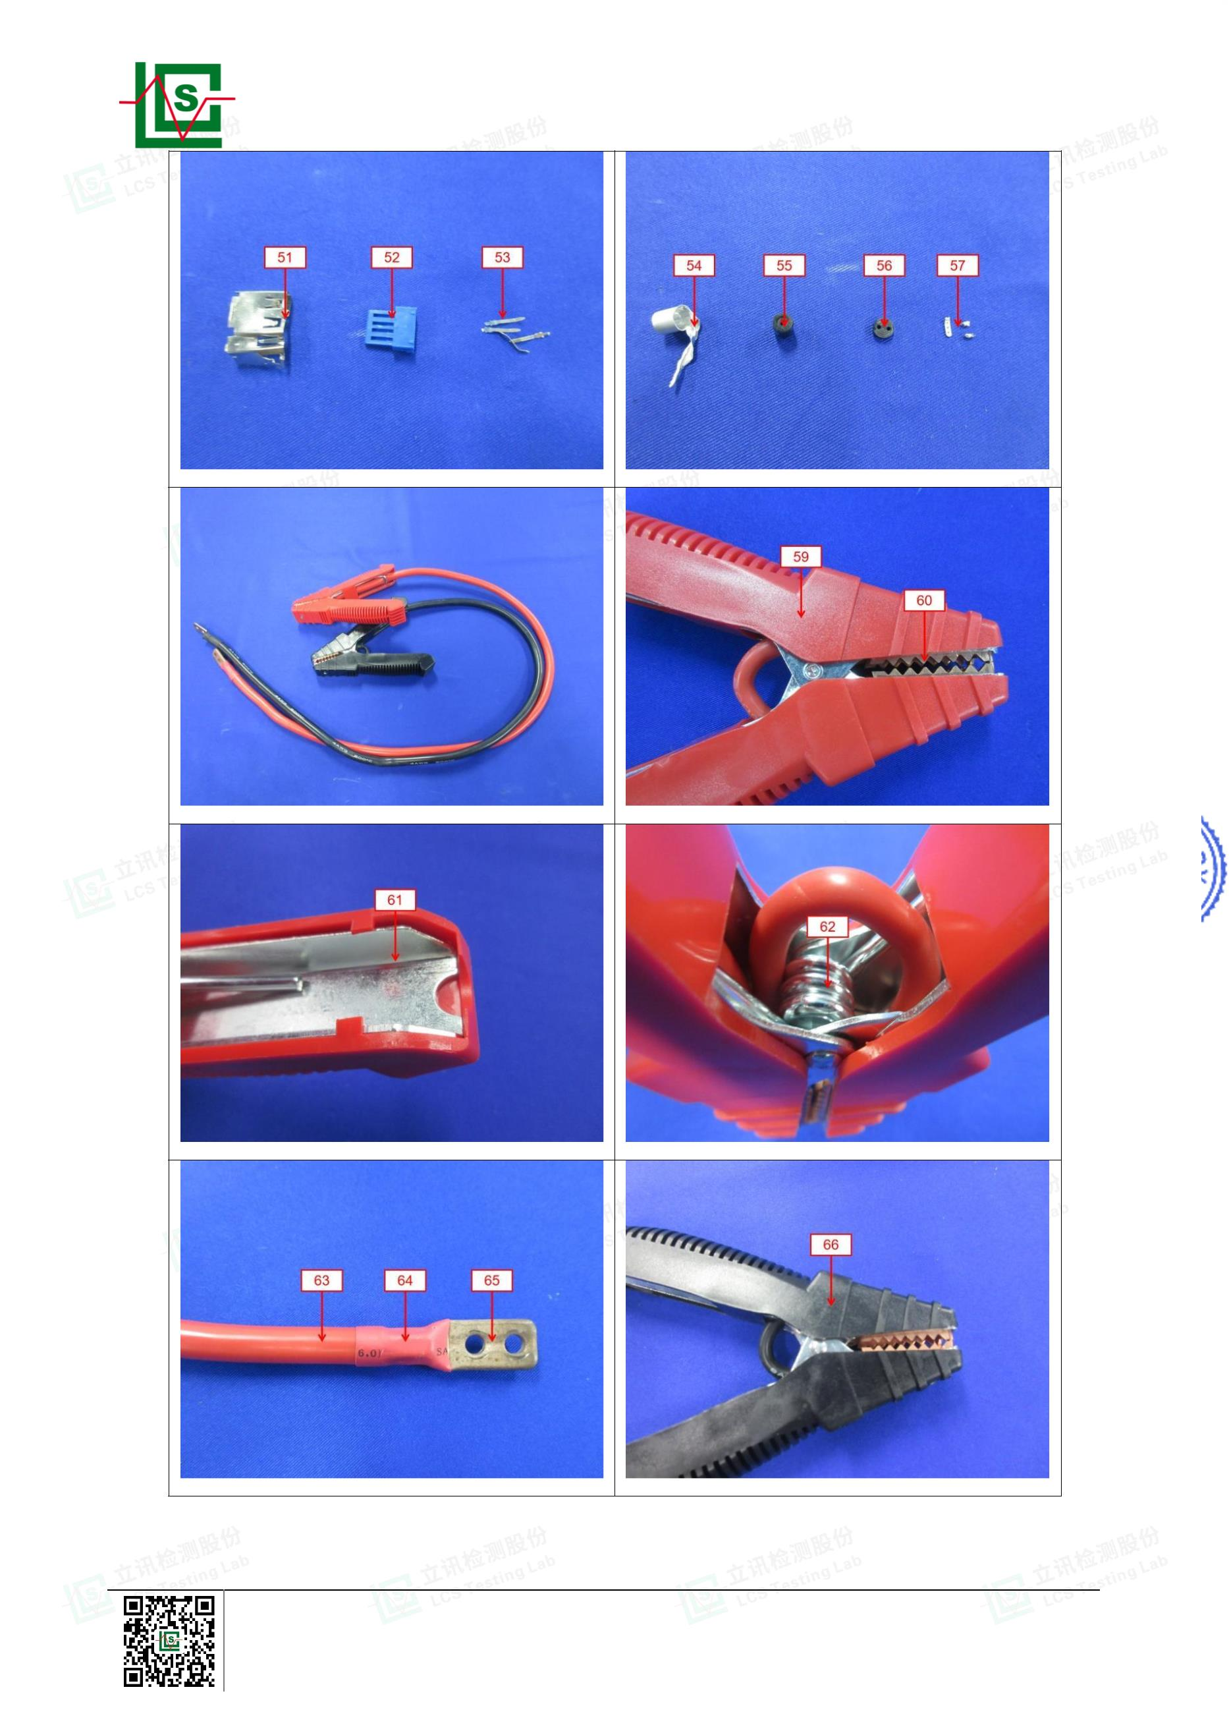

Page 19 of 21
Report No.: LCSA022523032R001
Shenzhen LCS Compliance Testing Laboratory Ltd.
Add: 901, No.40 Building, Xialang Industrial Zone, Heshuikou Community, Matian Street, Guangming District,
Shenzhen, Guangdong, China
Tel: +(86) 0755-82591330 | E-mail: webmaster@lcs-cert.com | Web: www.lcs-cert.com
Scan code to check authenticity
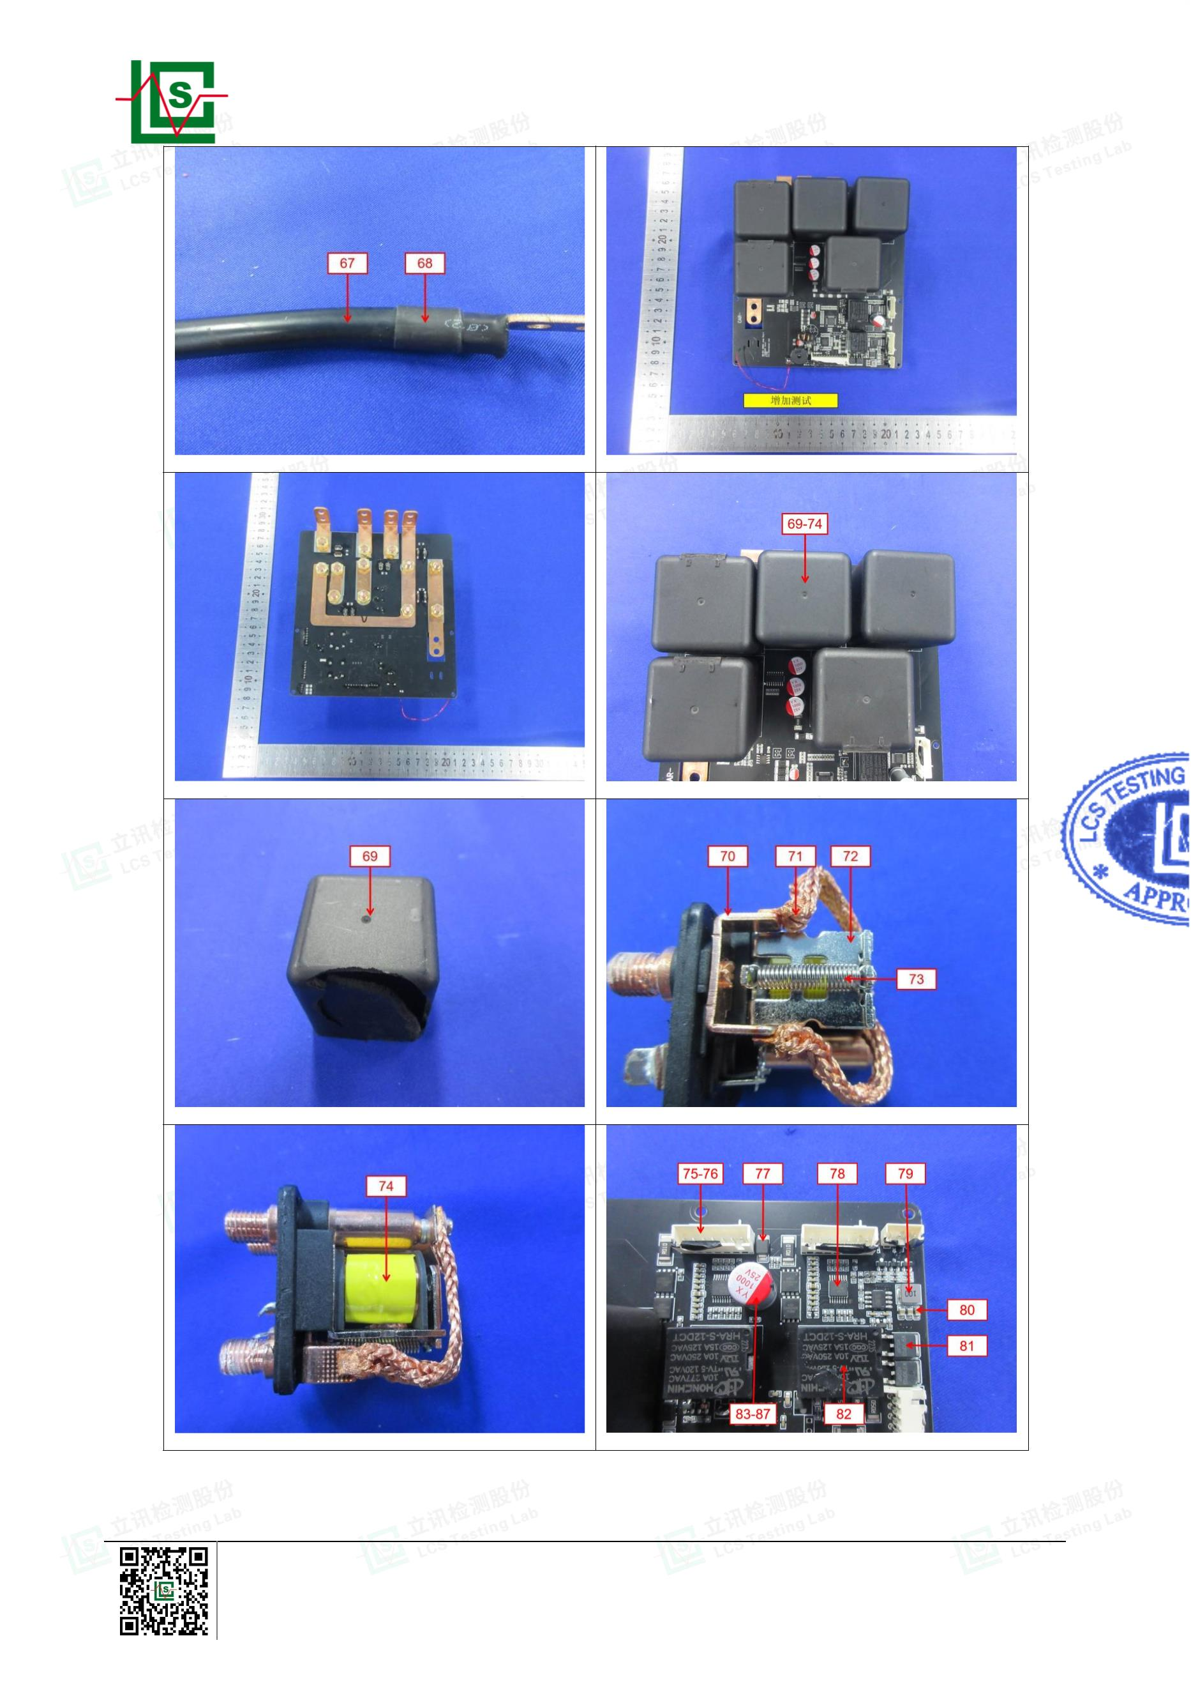

Page 20 of 21
Report No.: LCSA022523032R001
BLANK
Shenzhen LCS Compliance Testing Laboratory Ltd.
Add: 901, No.40 Building, Xialang Industrial Zone, Heshuikou Community, Matian Street, Guangming District,
Shenzhen, Guangdong, China
Tel: +(86) 0755-82591330 | E-mail: webmaster@lcs-cert.com | Web: www.lcs-cert.com
Scan code to check authenticity
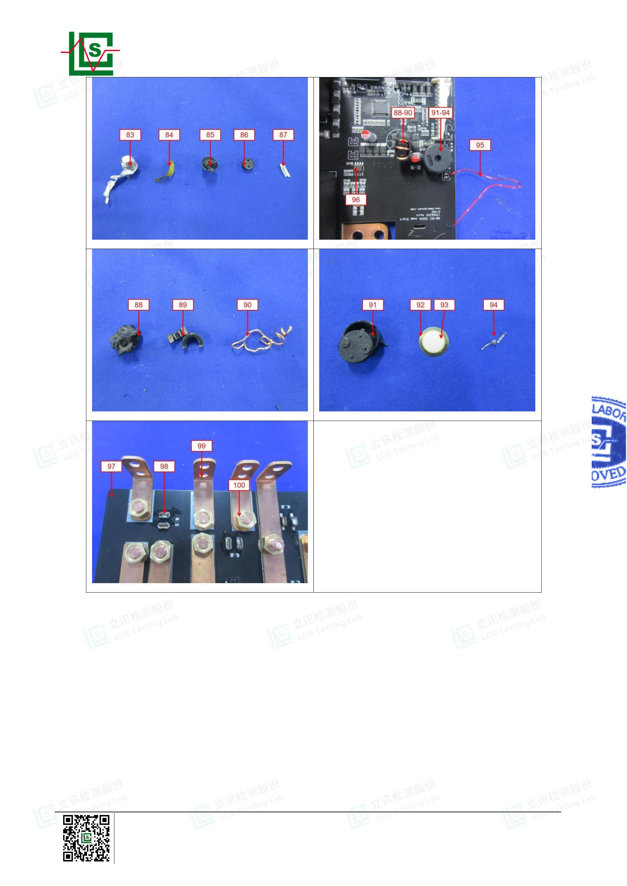

Page 21 of 21
Report No.: LCSA022523032R001
Statement:
1. The test report is invalid without the signature of the approver and the special seal for the company's report;
2. The company name, address and sample information shown on the report were provided by the applicant
who should be responsible for the authenticity which are not verified by LCS;
3. The test results in this report are only responsible for the tested samples;
4. Without written approval of LCS, this report can't be reproduced except in full;
5. In case of any discrepancy between the corresponding Chinese and English contents in the test report, the
Chinese version shall prevail.
Revision History
Revision
Issue Date
Revision Content
Revised By
According to customer's requirement, the company address
has been modified. The original product model was Zone A,
Floor 5, Cable Technology Building, Jiazitang Community,
Fenghuang Street, Guangdong District, Shenzhen, now
changed to B717, Tang Shang Building, No. 35 Xinqiao
Section of Guangdong Road, Shanghai Community, Xinqiao
Street, Baoan District, Shenzhen City, Guangdong Province,
China. All other information remains unchanged.
001
2024.03.27
Cuifang Yang
The LCSA022523032R001 report replaces the original
LCSA022523032R report, and the original report is invalid.
*** End of Report ***
Shenzhen LCS Compliance Testing Laboratory Ltd.
Add: 901, No.40 Building, Xialang Industrial Zone, Heshuikou Community, Matian Street, Guangming District,
Shenzhen, Guangdong, China
Tel: +(86) 0755-82591330 | E-mail: webmaster@lcs-cert.com | Web: www.lcs-cert.com
Scan code to check authenticity
